THAHASEER.P. M 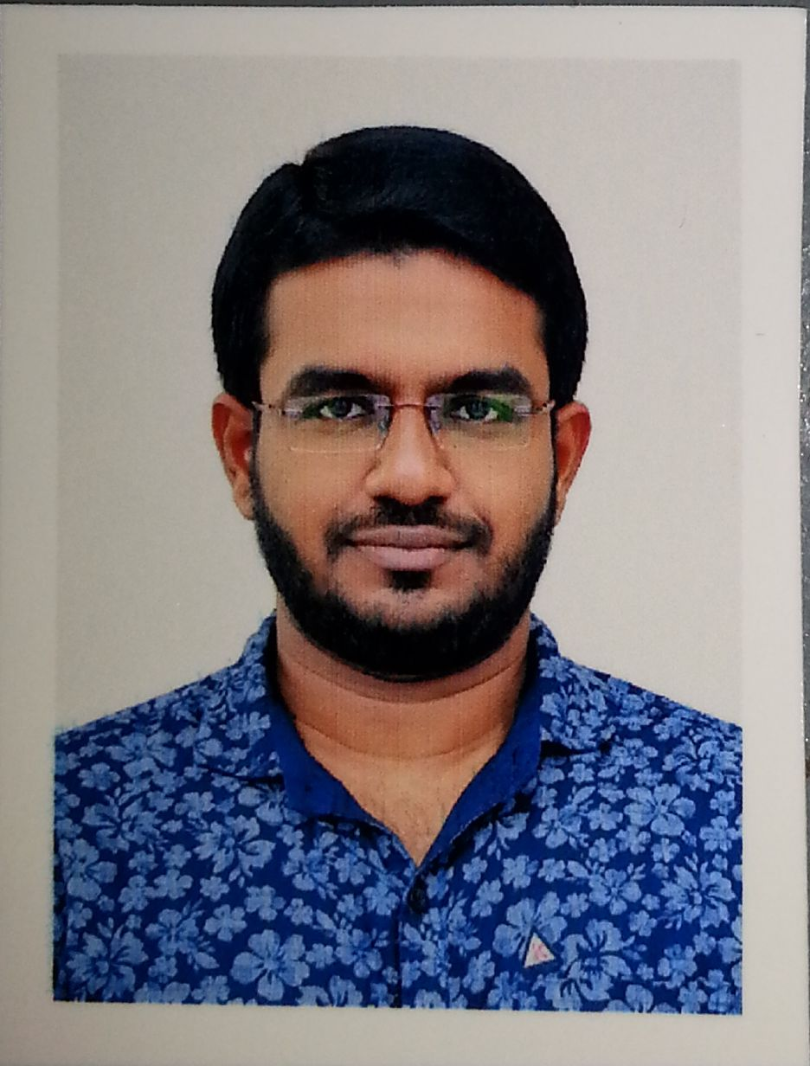

Mobile: 00971-527618341
Email : thahaseerpm@gmail.com
Career Objective

I am looking for a good position in the field of Mechanical Engineering in a prestigious company where previous skills and capabilities can be put to efficient use. I possess effective organizational skills and the ability to supervise a team and develop the final output.

Personal Details

Profile: Male, 27, Married, Indian, Muslim
Current Position: Unemployed
Current Location: UAE - Sharjah
VISA Status: VISIT VISA (Valid up to 22nd April 2016)
Passport number: H7378919

Educational Qualifications:

- Mechanical Engineering graduate from New Horizon college of Engineering in year 2010 with an aggregate 65 %.
- Passed higher secondary from Govt. Higher Secondary School, Mullasserry in year 2005 with 67 %.
- Passed High school from St.Joseph’s H.S. School in year 2003 with 76 %.

Organizational Experience

Organization: : Sharp Tanks and Structurals, Mumbai, India.
Duration: : 2014 Nov 27th -2015 Dec 31st
Designation: : Site Engineer
Project Description: : Adani Port,Surat,Gujarat

Responsibilities:
- Managing parts of construction projects.
- Overseeing construction work.
- Undertaking Surveys.
- Setting up sites and organizing facilities.
- Supervising contracted staff.
- Ensuring project meet agreed specifications,budgets or timescales.
- Liasing with clients, sub contractors and other professional staffs.
- Checking and preparing site reports, designs and drawings.
- Providing technical advice.
- Problem solving
- Ordering and negotiating product materials.
- Ensuring site safety.

Organization: : Mohammed Naser Al Sayer & Sons.Co,Kuwait
Duration: : 2012 June 10th to 2014 Nov 10th
Designation: : Technical Engineer, Entry Level, Service.

Responsibilities:

- Help to identify a mechanical problem by questioning the customer or doing a visual inspection or road test.
- Supporting the team leaders and technicians to resolve the technical complaints.
- Preparing Field Technical Reports and send to the distributor in order to implement Counter measures from producers for the specified concern.
- Studying Technical Informations and journals and explain to foreman and mechanics to ensure that this is applied during repair or maintenance.
- Prepare a repair order showing time, cost and labour estimates for service. Performing quality inspection to confirm the quality of job.
- Perform simple duties of normal nature with regard to experience level in any one of the assigned areas of trade specialization.
- Perform other related duties as instructed by workshop manager/workshop supervisor.
IT Skills
- Operating systems : Windows XP, 7,Vista
- Programs : Office Tools , AutoCAD, Primavera.
- Internet : Very good
- Programming languages : C,C++
Languages

- Hindi-Fluent
- English –fluent
- Malayala-Native
- Arabic-basic

Availability : Join with in one week after getting my employment visa
____________________________________________________________________________________
Declaration
I hereby declare that all information stated above are true to the best of my knowledge.

(Last Updated on March 9th 2016)

