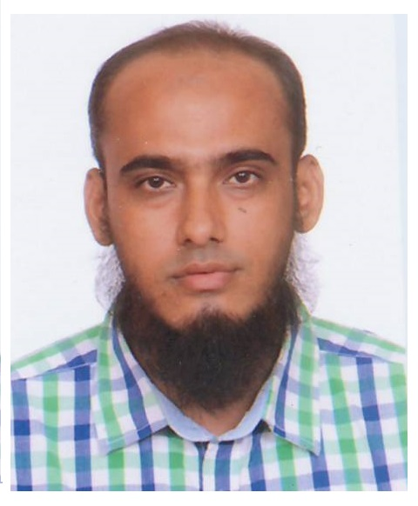
Mohammad Ruhul Alam Shahnowaz
Passport Number: BB0932701
Visa Number: 132016171798
Visa Type: Work-Yearly Resident
Mobile: +974 77630386
Email: shahnowaz77@gmail.com

Professional summary
Motivated and accomplished post graduate with strong skills and experience
Seeking a position to utilize my skills, educational background, computer knowledge and ability
To work well with people
To ensure the company's success
To improve company's operation and profitability

Skills
Data Entry
Data Processing
Microsoft Office Proficiency
Administrative Support
Sales and Marketing
Online/Email Marketing
Customer Support
Web Search

Education
Master of Science in Mathematics - National University, Bangladesh
Bachelor of Science with Honours in Mathematics - National University, Bangladesh

Language Skill
English and Hindi

Computer Literacy
Fluent in the MS Windows operating environment
Advanced training and experience in the application and usage of Microsoft Office, Data Entry, Data Processing, Online/Email Marketing
Worked as a freelancer in Search Engine Optimization
Sounds knowledge in Web Design (HTML and CSS)
Familiar in Google’s Blogger

Experience
Worked in a Recruiting Agency as a Business Development Executive.
Worked in a Computer Training Institute as Administrative Assistant.

Summary of qualifications
Respond to the client queries regarding the products in a timely fashion.
Establish strong customer relationship by providing accurate and timely information to customers regarding inquiries such as products, pricing, quotes and issues/concerns.
Travel to customer sites and tradeshows to promote company’s products and services.
Utilize Microsoft Office skills to provide word processing and spreadsheet program services.

