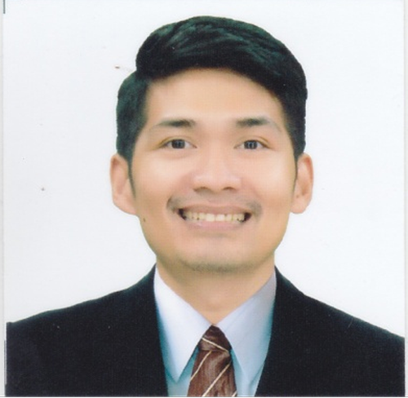
ABIDIN PUNGUTAN LAZO
Block 4 Lot 5 Herminia Street Phase 5 Palmera Homes
Santa Monica Novaliches, Quezon City 1117
Res. Tel. No.:02.7340.46.33
Mobile No.: 0917.498.65.97
E-mail add: lazo.abidin@gmail.com

OBJECTIVE To be able to maximize the professional competence and strength garnered through years of experience and training towards the
effective & efficient performance of functions, duties &
responsibilities.

SPECIAL
SKILLS
- Computer Literate
- Proven Communication Activities
- Self-motivated; able to set effective priorities.
- Hardworking, efficient and a good team player.
- Can work under pressure with minimum supervision.

WORKING
EXPERIENCE
Gateway Motors Cebu Inc.
Mitsubishi Gateway Fairview
June 1, 2023 - Up to present
Position: Sales Executive
- Promote products and services to customers and negotiate contracts with the aim of maximizing profits.
- Negotiating price; completing sales or purchase contracts; explaining provisions; explaining and offering warranties, services, and financing; collects payment; delivers automobile.

Zoomhub Inc.
Geely Quezon Avenue
January 2021 - April 2023
Position: Sales Executive
- Promote products and services to customers and negotiate contracts with the aim of maximizing profits.
- Negotiating price; completing sales or purchase contracts; explaining provisions; explaining and offering warranties, services, and financing; collects payment; delivers automobile.

Goldshine Pharmaceuticals Inc.
Quezon City
April 2020 – December 2020
Position: Trade Marketing Associate
- Developing, planning and implementing marketing strategies and advertising activities.
- Assist with organizing promotional events.
- Trade check different stores and observing competitor’s strategies.

Diamond Motor Corporation
Fairview Branch
August 2018 – March 2020
Position: Sales Consultant
- Understands automobile by studying characteristics, capabilities, and features.
- Qualifies buyers by understanding buyer's requirements and interests.
- Negotiating price; completing sales or purchase contracts; explaining provisions; explaining and offering warranties, services, and financing; collects payment; delivers automobile.

UBER Philippines
Mandaluyong City Philippines
June 2016 – April 2018
Position: Operator/Driver
- Managing/Monitoring the sales income.
- Can manage different types of people.

AVIDA Land Corp.
Mandaluyong City Philippines
July 2013 – December 2015
Position: Property Specialist
- Sell property for clients. Perform duties, such as study property listings, interview prospective clients, accompany clients to property site, discuss conditions of sale, and draw up real estate contracts.

Zahnfabrik Philippines, Inc.
Taguig City Philippines
July 2012 – February 2013
Position: Dental Territory Manager
- Responsible for building and developing business relationship and good report to target doctors.
- Responsible for targeting and developing new accounts in
the territory and at the same time maintaining existing accounts.

Spencer Foods Corporation
Pasig City, Philippines
April 2011 – January 2012
Position: Accounting Staff – Accounts Payable
- Preparing of AP Invoice, Check Voucher, Expanded Withholding Tax, Aging & Banking process.
- Assist the department head in planning and developing policies for internal control.
- Monitoring of overall routine system process such as application, renewal and retirement of permits.

VINCI Construction OEA Grands Projets,
Tripoli, Libya
July 2009 – May 2010
Position: Assistant Document Controller
- Maintain updated data base, receiving and filing of all in-coming and out-going files for all documents, prepare debit note from different site every month.

VINCI Construction OEA Grands Projets,
Tripoli Libya
January 2009 – June 2009
Position: Timekeeper
- Checking workers on site, make daily report, prepare timesheet every month and perform day to day clerical jobs.

House of Representatives Electoral Tribunal (HRET)
July 2008 - August 2008
Position: Volunteer Watcher / Revisor
- Assure that the number of ballots/votes is equal to the number in the master list, revise the master list if ever there are corrections during the counting.

EDUCATION 2003-2007 National College of Business and Arts Fairview Branch
Bachelor of Science in Business Administration major in Management Accounting.

