Page 1 of 2

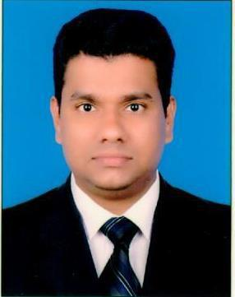

**RESUME**

**AMAL THOMAS**

Mobile Phone: **+91 7736010373**

E-mail: **amalthomas916@gmail.com**

**POSITION DESIRED: Sales Executive**

**CAREER OBJECTIVE:**

To be employed in a position where I can apply my knowledge and experience in sales and marketing field, To search for knowledge and vital experience that would eventually result in the company’s growth and success as well as to achieve personal fulfillment, career improvement, not only in the financial aspect but also of greater importance in moral and spiritual upliftment

**SUMMARY OF THE EXPERIENCE:**

***Total years of Experience: THIRTEEN YEARS***

**Qualification** **:** **PLUSE TWO**

**PROFESSIONAL EXPERIENCE**

**COLLECTION EXECUTIVE**

MOTHOOT CAPITAL SERVICE.

MG ROAD

ERNAKULAM (3 Years)

**COLLECTION EXECUTIVE**

HONEST ASSOCIATES

KADAVANTHARA

ERNAKULAM (6 Months)

**OTHER PROFESSIONAL EXPERIENCE**

1. **SALES EXECUTIVE**

**JOYALUKKAS JEWELLARY INDIA KERALA, TAMILNADU**

1. ***To 2012)***
2. **SALES EXECUTIVE and FLOOR INCHARGE MALABAR GOLD AND DIMOUNDS**

**DOHA QATAR**

**2013 to 2021**

CURRICULUM VITAE

Page 2 of 2

**OTHER EXPERIENCE**

**TOUR OPERATOR**

**HOLIDAY TOURS**

**TOUR PACKAGES AND AIR TICKE**

**(One Year)**

***EDUCATIONAL BACKGROUND:***

1. **Secondary School**

Panangad VHSS, Panangad p.o (2002)

1. **Pulse Two**

Panangad VHSS, Panangad p.o (2003-2005)

***ADDITIONAL QUALIFICATION:***

1. Diploma in Gem Identification

***PERSONAL BACKGROUND:***

|  |  |  |
| --- | --- | --- |
|  |  |  |
| Date of Birth | : | 30/05/1985 |
| Marital Status | : | Married |
| Nationality | : | Indian |
| Languages Known | : | English, Hindi, Malayalam, Tamil |
| ***PASSPORT DETAILS***: |  |  |
| Passport No | : | L 6560841 |
| Issue date | : | 15/01/2014 |
| Expiry Date | : | 14/01/2024 |
| Place Of Issue | : | Cochin |
| ***DECLARATION*** : |  |  |

I hereby declare that the above particulars are correct to the best of my knowledge and belief.

**AMAL THOMAS**

CURRICULUM VITAE