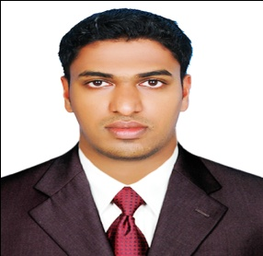**ABDUL SALAM . P**

**Mobile 00974-50818458**

**00974-70679081**

**DOHA QATAR**

**Email punnakkan865@gmail.com**

**CAREER OBJECTIVE**

Seeking a challenging suitable position with a progressive institution where my accumulated experience and provides an opportunity to grow with the organization.

## EDUCATION

AUTO CAD ELECTRICAL DRAFTING CADD CENTER PAYYANUR 2009

ITI Electrician Ampere Technical Institute & ITC April 2008

Board of Public Examination - March 2007.

Secondary School Leaving Certificate PJHS, Kannur - March 2005

**PROFESSIONAL QUALIFICATION/ TRAINING**

* Diploma in Accounting from Tally Solution Pvt. Ltd. Bangalore, India
* Certified in Type writing
* Diploma in Computer Application
* Certified in MS DOS
* Diploma in Store Keeping
* Certified in MS Office
* Certified in Hardware and Networking

# SOFTWARE EXPOSURE

* Operating system : MS Windows 98, 2000, ME and XP
* Utility package : Tally. Office 2000, 2003, 2007
* Typing skill : 85 wpm

**PERSONAL SNIPPETS**

Name **:** Abdul Salam

Father’s Name **:** Abdul Rahiman AV

Gender **:** Male

Nationality **:** India

Date of birth **:** 05/05/1987

Passport number **: N1163910**

Driving license Qatar : **28735641265**

Languages Known **:** English, Hindi, Malayalam ,Arabic

**PROFESSIONAL EXPERIENCE**

* **FREE LANCE WORKE DOHA QATAR**

**Position as a Driver - April 2014 Still Countinew**

* **KMTRAIDING LLC ABUDHABI UAE**

**Position as a MEP ( Electrician &Plumbing - July 2010 till Jun 2013**

* **AVR KANNUR, KERALA**

**Position as a MEP ( Electrician &Plumbing)– June 2008 till May2010**

**DECLARATION**

I do hereby declare that the information enclosed above is true and I think you in advance for considering my application**.** I will be able to prove myself as an asset to your organization.

ABDULSALAM