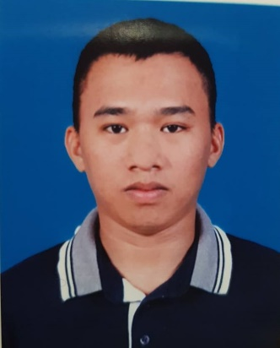**Mohammad Sayeed Mamasabang Sali**

Khalid bin Hazam street, Madinat Khalifa South

Contact Number: +97455346039

Email address: [mohammadsayeedsali@gmail.com](mailto:mohammadsayeedsali@gmail.com)

VISA type: QID (NOC upon Request)

Qatar Driver’s License Validity: 30/11/2027

**Work Experience:**

**January 2017 – Present | Delivery Driver**

**Al Mana Mcdonalds Qatar**

**Doha, Qatar**

* Provided quality customer service through positive and professional interaction with customers in person or by phone
* Performed other assigned workstation duties including making quality products, preparing ingredients and taking orders
* Worked as part of a team and assisted each other by being on time for their shift
* Accurately processed order paperwork and payment transactions and execute cash management duties
* Protected the company's assets by maintaining organized, safe, and clean work areas; complying with safety and security standards at all times

**April 2013 - October 2015 | Private driver**

**Cotabato City, Philippines**

* Responsible for picking up clients at their place of residence and dropping off
* Driving clients around town to business meetings as well as private airports and hotels
* Being able to multitask and be on time
* Neat and professional appearance and treating clients with the highest respect and dignity

**Education:**

National High School Main Campus

Cotabato City, Philippines

**PERSONAL DATA:**

Date of Birth: October 30, 1993

Gender: Male

Religion: Islam

Nationality: Philippines

Civil Status: Married

Languages: English, FIlipino