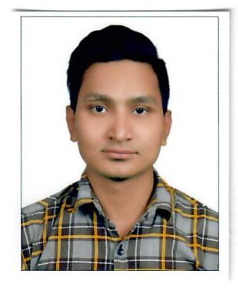 **Sajid Ansari**  [ansaree12@gmail.com](mailto:ansaree12@gmail.com)

PH: +974 7729 2607

DOB: 25 JULY 1996

**Objective:**

Looking for the career opportunity that both challenging and reward in your highly reputed company.

**Key Skill:**

* Data entry skill
* Software and hardware pc problem shouting
* High typing speed and accuracy
* Communication
* Teamwork
* Problem solving
* Leadership
* Organization
* Self-motivated
* Ability to work under pressure
* Creativity.

|  |  |
| --- | --- |
| **AUTO SITE SPARE PARTS CENTER, QATAR**  **Job title**: Sales executive | **1stSept 2020 to 28 Feb 2023** |

**Duties and responsibilities:**

|  |
| --- |
| • Understand Agriculture machinery operations and parts / consumables  • Check all parts in parts catalog and manuals as per equipment model and serial number  • Assist all customers (retail and workshop) in selecting required parts in a professional and efficient manner.  • Informs customers of companion parts requirements and specials and ensures that the customer is exposed to the full product line.  • Answer phone calls, providing price quotes and other information in professional manner.  • Provides high level of service to internal and external customers  • Notifies Parts Manager of out of stock part or shop materials that need immediate attention.  • Notifies the service advisor and the customer when special ordered parts have been received.  • Follow up on back-ordered parts from supply chain team.  • Assist outside sales representatives with their orders.  • Make sure all internal requests for parts are posted and goods movement is done.  • Ensures that all customers receive their copy of the invoices and sign receiving of goods  • Issues credit for parts returned, ensuring that the original invoices or its number is available so that the purchase and pricing can be verified.  • Update technical knowledge by reading all the technical reports from suppliers and knowing the new update information in the EPC.  • Keeps orderly records of all parts orders from workshop  • Sets up orders for daily shipment, delivery or pick up  • Participate in approved training programs and keep himself undated with units sold from sales department.  • Maintain professional appearance and carryout any temporary assignments assigned by manager |
|  |

|  |  |
| --- | --- |
| **FIXINGS TRADING CO. QATAR**  **Job title**: Showroom incharge | **10thoct 2016 to 30 july 2020** |

**Duties and Responsibilities:**

* Supervise all sales and marketing activities in the showroom.
* Perform general office duties such as ordering supplies, maintaining records management systems, and performing basic bookkeeping work
* Prepare invoices, reports, quotation, memos, letters, financial statements and other documents, using word processing, spreadsheet, database, and/or presentation software.
* Compare prices, certifications, lead times and negotiate with suppliers
* Prepare then issue purchase orders
* Provide quality service by enforcing quality and customer service standards.
* Contact and send order to supplier if stock less
* Supervise cash and payment systems in accordance with company procedures and policies.
* Supervise costs and overheads, and all factors affecting the profitable performance of the showrooms.
* Supervise all stock movement activities: in/out, transfer, sales etc and responsible of showroom stock in a way to eliminate stock shortage and perform stock replenishment in an efficient manner and on due time.

**Academic Qualification**

|  |  |  |
| --- | --- | --- |
| **Highest Academic Qualification** | **Board** | **Passed Year** |
| High School | Prabhat Secondary Boarding School | Year Completed:2012 |

**Technical Institutional Course**

**Software course**

MS-Office Package in MS-word, MS-PowerPoint, MS-Excel, Database Management, Tally & ERP Software Well Use User, Equal opportunities training.

**Hardware Courses:**

Computer Fundamental, Command Prompt, Assembling Computers Components, OS (Operating System Installing), Troubleshooting etc.

**Language Known:** English, Nepali, Hindi

**Nationality:** Nepali