***Curriculum Vitae***

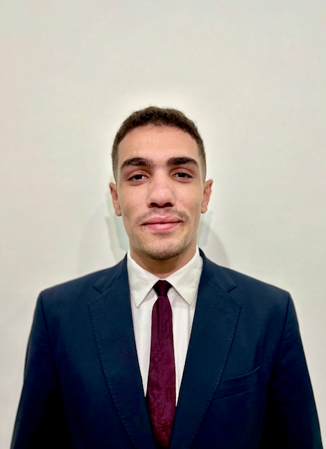

Aziz Somrani

## Mobile: (+974) 31682859 E-mail: azizsomrani328@gmail.com

## Born on 28/04/2000 – 23years old– Single

## Visa Status: with NOC

## Languages: Arabic, English and French

**SKILLS AND PROFILE**

*Dear Human resource Department.*

*Kindly accept my interest to apply for your company.*

*I am an ambitious and motivated person seeking for a challenging position.*

*Attached are my contact details and detailed CV for your review and consideration.*

*Thank you,*

*Sincerely.*

**PROFESSIONAL EXPERIENCES**

### DIESEL January 2022 to October 2023

**Assistant Manager** *DIESEL Tunis City & Tunisia Mall*

-Maximizing sales to achieve shop target by using expert selling skills.

- Strong desire and capability to provide excellent service customers.

- Offering top service to our clients.

-Establishing long term relationships with customers.

-Consulting, promoting, merchandising, cashiering, inventorying.

-Being directly responsible of any store that I would be part of.

- Reception of products, stock levels, location of shelves.

- Career management (training, promotion and bonuses).

- Team building, establishment of schedules.

- Definition of sales targets.

- liaising between management and staff.

- Management of stock and supplies.

- setting up of the collection in the boutique.

- Reception of customers, advice and sale of products to customers.

**ARMANI** **EXCHANGE** **August 2020 to December 2021**

**Senior Client Advisor** *ARMANI EXCHANGE* Tunis City & Tunisia Mall

- Creating a shopping experience that will make the customer feel welcome and comfortable

- Meeting personal and store sales target

- Demonstrating superior product knowledge to customers.

- Maintaining after sales relationship.

- Ensure that the store is kept clean and organized.

- Conducting stock check and reports when stock is low.

- Helped shrinking inventory discrepancy to almost less than 500 DT in Store.

- Helped in reducing off-season item by notifying the store manager about the slow moving items.

### ZARA February 2019 to March 2020

**Client advisor** at ZARA *downtown store & Tunis City*

-Welcoming customers in store, accompanying and advising them on the choice of products adapted.

-And ensure that the brand Standards are always met.

-Always increasing the team spirit, motivating my colleagues and empowering other with my positive and energetic.

**TRAINING AND CERTIFICATION**

**School year 2017-2018: Baccalaureate level in Economics & Management at** *Carthage Presidency High School*

**Organizational and Managerial Skills:**

**Leadership, very good organizational skills and team management skills. Handling of difficult customer.**