Curriculum Vitae

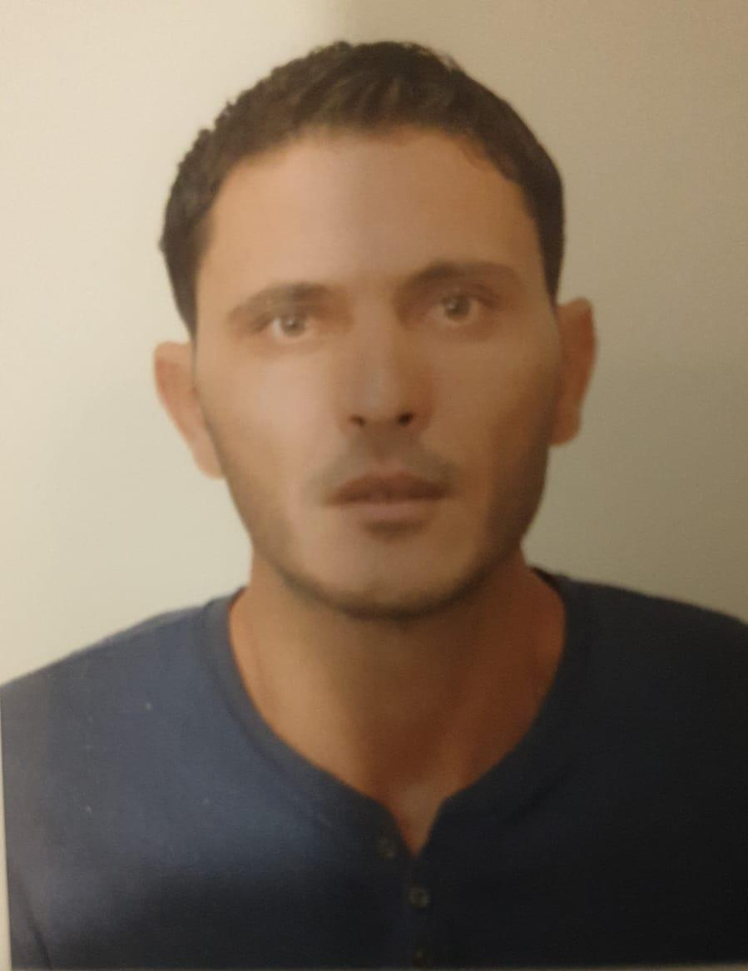
Personal Information

Name: Ahmed Samti
Mobile: +974 70956419
Email: ahmedsamti0458167@gmail.com
Nationality : Tunisian
Visa Status : Transferable RP

---------------------------------------------------------------------------------------------------------------------------------------------------------
Objective
To progress in a reputable large successful organisation with greater responsibility and opportunity to work in a demanding and challenging environment allowing me to excel.

Skills
- Organizational Skills.
- Teamwork Capacity.
- Initiative.
- Communication Proficiency.
- Multiple language skills: Arabic, French and English
EDUCATION
Secondary Education Lycee 2nd March 1934 Tunisia.

PROFESSIONNAL EXPERIENCE:

December 2021 – Present:

Boudront
Position:spare parts sales

- Promoted sales of correct auto parts to repair customer issues with the vehicle in-store, and keep an up-to-date record of all transactions made.
- Followed prescribed cash, credit and check processing procedures for merchandise, as per company policy.
- Arranged and planned showroom inventory to maximize sales and increase customer satisfaction.
- Attended selective training as recommended by senior management, to enhance learning and knowledge in responsibilities maintained.
- Efficiently taken care of customer complaints and concerns to the satisfaction of both parties.
- Recommended substitute parts or show customers how to modify parts.
- Examined parts for defects.

April 2017- May 2019:
Bin Omran Trading & Contracting (Asphalt Plant) –Doha
Position: Weighbridge Operator

-checking and logging drivers’ details as they come in and out of the site
-weighing lorries when they arrive and leave
-filling in inspection sheets
-booking other site visitors in and out
-updating records on computer systems
-answering phone enquiries
-dealing with other administrative tasks

November 2014- April 2017:
Trelco International Group –Doha
Position: Site Supervisor

-Schedule the trailers trip timing and control their weight and conditions.
-Overseeing site operations
-Supervising sub-contractors and other labour workers
-Maintaining health and safety records
-Taking and keeping records of weight bridge
-Responsible for staff time keeping
-Responsible for training orientations of all new employees
-Communicate with clearance agent and local port authorities to receive cargo and discharge vessels.
-Responsible for logistics operations for loading and discharging goods from and to site.

January 2011 to October 2014:

Ministry of Agriculture - Tunisia

Position : General Foreman

- Ensure that workers are carrying on work as per schedule.
- Responsibility to check on the work schedule with Engineers and landscapers.
- Responsible for allocating the duties to the workers according to their capabilities.
- Ensure the safety precautions are properly implemented during construction.
- Deal with any sort of problems with workers.
- Assist hiring and firing workers.
- Ensuring schedule and time keeping.
- Train the new workers.
- Motivate workers to do the work with higher efficiency and ensuring that the work is completed on time properly.

LANGUAGES
- Arabic : Excellent ( Written and spoken)
- English: Excellent ( Written and spoken)
- French: Excellent ( Written and spoken)

