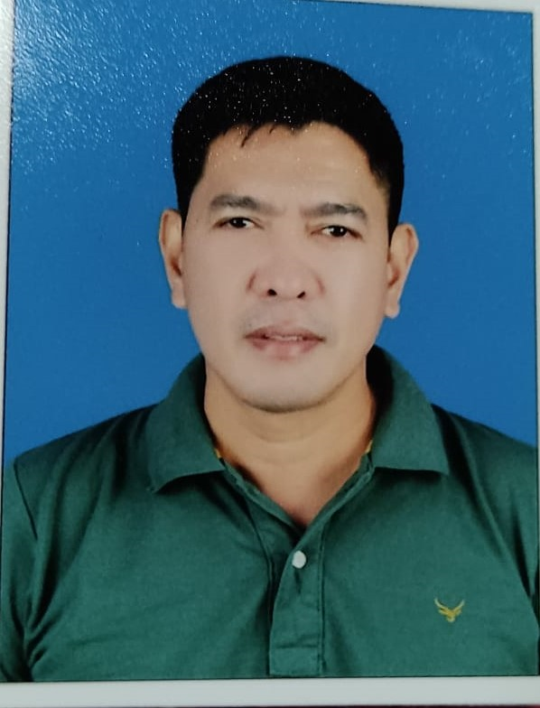
NESTOR C. TEJONES JR.
Mobile No.: +97450632735
Email Address: nestortejones@yahoo.com
Visa Type: WORKING VISA W/ NOC

OBJECTIVES:
To work in a reputable company or organization wherein I can utilize my knowledge and skills to the fullest and be the asset of the company.
EMPLOYMENT RECORD:
ASSISTANT CHEF
5 MINUTE BURGER
OCT 2021 – MAY 2023

Duties & Responsibilities:
- Responsible for preparing and making all the sauce that needed in the kitchen systematically and accurately.
- Assisting the Head Chef to prepare, plan and cook other food items to ensure the highest quality services and experience for customers
- Help the kitchen organize and running efficiently. Ensure proper food handling, sanitation and following food storage procedure.
- Monitoring the customers online for delivery.
- Assisting the in-charge in purchasing some stocks that are needed in the kitchen.
- Assisting the accounts for calculating the expenses as well as the stock staking if necessary.
- Washing and cleaning all the utensils and equipment in the kitchen as well as cleaning the restaurant.

MACHINE TECHNICIAN / STORE KEEPER
MODERN TRADING SYSTEMS
PART- TIME (July 2020– April 2021)

▪► Repairing the machine from customer (Cleaning machine like Vacuum Cleaner, Scrubber machine, Sofa cleaner, Walk behind Scrubber drier Machine, Car Polisher Machine, High Speed Polisher machine, Steam Cleaner, Extraction Machine, High Pressure Washer and some kitchen equipment.
▪► Cleaning, Arranging, and Counting the All remaining stocks in the store. Sorting, Labeling and arranging all the spare parts, consumable items and machine inside the store. Removing all the items that are already scrap. Checking all the machine that can be use and can be sell again. Checking the spare parts that still can be use from the old machine.
- Have knowledge in assembling the cleaning machine like vacuum cleaner and single disc scrubber machine

Telecom Technician June 2020
Ooredoo / Vodafone 4G/5G IBS and Outdoor Installation Projects
PENIEL General Services

Duties & responsibilities :
- Assisting the Site Engr. for outdoor installations of 4G/5G Ooredoo/Vodafone projects. These require full installation from BBU, DC system, RRU’s. Fiber cables and antenna side.
- Assisting the Site Engr. MW installations both traditional and Eband link including TX cabinet, IDU, DC power termination and MW antenna (0.3, 0.6 & 0.9)
- Assist the Site Engr. for Conducting TSSR and site survey for new and existing sites for Vodafone MW implementation SWAP as well as LOST for new far ends candidates.
- Assist the Site Engr. for the rectification for the readiness of site acceptance.
- Assist the Site Engr. for IBS/DAS installations for Ooredoo/Vodafone Projects. These require full installation from BBU and DC system, fiber optic cable laying, components installation and antenna.
- Assist the site engineer for the coordination of site access requirements.

Consultant’s Laboratory Technician July 2014 – August 2019
CONSULTANT / DPWH Project Manager’s Office
DPWH RMC 1 UPMO Field Office, Brgy. Tambubong, San Rafael Bulacan
Plaridel Bypass Road Project, Phase III & IV, CP3, Bulacan, Phil.
Project Cost : 1.092 Billion (Php)
Type of service rendered: Construction and Supervision
Duties & responsibilities :
- Conducts Slump Testing of concrete mixes for roads, bridges and other miscellaneous structure.
            - Conducts Compressive & Flexural strength test of concrete for roads and bridges.
            - Conducts Soil and Aggregates testing such as Gradation, Liquid Limit, Plastic Limit, California Bearing Ratio, Laboratory Compaction (Standard & Modified), Unit weight, Soundness Test, Abrasion test, Field Density test (in-placed embankment), Base & Sub base courses, Crushed aggregate base course, and Cement treated base course (CTB) using sand cone method.
            - Assist the Consultant’s Material Engineer in the preparation of reports and documentations such as Materials test requirements (MTR), Materials Logbook, Quality Control Program (QCP), Sample cards, Test Results, etc.

Contractor’s Laboratory Technician May 2013 – July 2014
C.M. PANCHO CONSTRUCTION INC.
Southern Tagalog Arterial Road Star Proj., Batangas, Philippines
Project Cost :2.315 Billion (Php)
Type of service rendered: Construction and Supervision

Duties & responsibilities :
- Conducts Slump Testing of concrete mixes for roads, bridges and other miscellaneous structure.
- Conducts Compressive & Flexural strength test of concrete for roads and bridges.
- Testing of Bituminous Surface Courses (Binder & Wearing ) and Stone Mastic Asphalt
- Determination and calculation of Air voids, voids filled with Asphalt, Voids in mineral Aggregates, Density & thickness determination of Core samples.
- Conducts Soil and Aggregates testing such as Gradation, Liquid Limit, Plastic Limit, California Bearing Ratio, Laboratory Compaction (Standard & Modified), Unit weight, Soundness Test, Abrasion test, Field Density test (in-placed embankment), Base & Sub base courses, Crushed aggregate base course, and Cement treated base course (CTB) using sand cone method.
- Assist the Consultant’s Material Engineer in the preparation of reports and documentations such as Materials test requirements (MTR), Materials Logbook, Quality Control Program (QCP), Sample Cards, Test Results, etc.

Senior Laboratory Aide January – November 2010
J.E. MANALO CONSTRUCTION
Plaridel Bypass Road Project, Phase II, CP2, Bulacan, Phil.
Project Cost : 1.204 Billion
Type of service rendered: Construction and Supervision
Duties & responsibilities :
            - Assist in the conduct of Slump Testing of concrete mixes for roads, bridges and other miscellaneous structure.
            - Assist in the conduct of Compressive & Flexural strength test of concrete for roads and bridges.
            - Assist in the conduct of Soil and Aggregates testing such as Gradation, Liquid Limit, Plastic Limit, California Bearing Ratio, Laboratory Compaction (Standard & Modified), Unit weight, Soundness Test, Abrasion test, Field Density test (in-placed embankment), Base & Sub base courses, Crushed aggregate base course, and Cement treated base course (CTB) using sand cone method.
            - Assist the Laboratory Technician in the conduct of different Sampling and Testing of Construction Materials.

Toll Teller January 1998 – January 2006
PHILIPPINE NATIONAL CONSTRUCTION CORP. (PNCC)
Edsa, Corner Reliance St., Mandaluyong Quezon City
Type of service rendered: Other services of special studies

Duties & responsibilities
- Collect Toll Payments, Provide customers’ receipts, Calculate toll amounts, give driver directions, Open & Close toll booths.

EDUCATIONAL BACKGROUND:

COLLEGE / TERTIARY : Basic Seaman Training Course
PMTC, St. Mesa, Manila, Philippines
INCLUSIVE YEAR : 1992 - 1993

VOCATIONAL : Electrical Technology

CSAT Occidental Mindoro, Philippines
INCLUSIVE YEAR : 1993 -1994

HIGH SCHOOL / SECONDARY : Brgy. Tilik National High School
Occidental Mindoro, Philippines
INCLUSIVE YEAR : 1987 – 1991

RELEVANT SKILLS:
            - Have Certificate /Training in HVAC in PIIQ
            - Have Certificate / Training in MOTOR CONTROL & ELECTRICAL in PIIQ
            - Professional Driver in Philippines
            - Knows Basic Computer / Knowledge in Butchery and Cooking

PERSONAL DATA:
ADDRESS : Saeed Bin Jubair St., Al-Aziziya, Doha Qatar
DATE OF BIRTH : August 7, 1974
CIVIL STATUS : Married
NATIONALITY : Filipino
SEX : Male

CHARACTER REFERENCES:
MR. SAUOD AL-AHBABI
OWNER-MNGR.
5 MINUTE BURGER

MR. AZMI KHIRALLAH
GEN. MNGR.
MODERN TRADING SYSTEMS

ENGR. BASILIO M. ELUMBA
Project Manager – DPWH RMC1-UPMO
Plaridel Bypass Road Project, Phase III, CP 3, Bulacan, Philippines

I hereby certify that the above statement is true and correct to the best of my knowledge and belief.

______________________
NESTOR C. TEJONES JR.

