SHIEK IRFAN

MOHAMMED

Experience 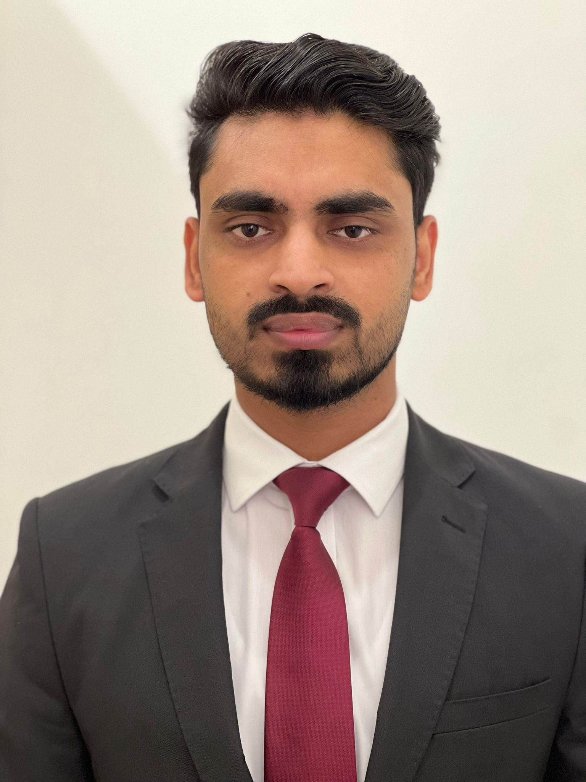

**Sales Consultant / Cashier** - January 2022 to PRESENT

**BRANDS TRADING CO. Qatar (JANUARY 2022 - PRESENT)**

**TURK FASHION Qatar - Part Time (Sept. 2021 - Dec. 2021)**

* Dealing with customer to attend to their inquiries.
* Check and organize products and stocks.
* Coordinate with management and superiors for the products and inventories.
* Preparing daily, weekly, and monthly reports.
* Faxing, scanning, and copying of all reports and inventories.
* Perform admin jobs as per required by superiors.

**BROTHERS TRADING PLACE GRAND MALL - 2018 to 02/2019**

**BROTHERS TRADING PLACE SAFARI MALL**

**August 2020 - Augsut 2021**

**SPORTS CORNER - (KATHAMANDU) Year 2015 - 2018**

**Education**

**High School Graduate**

* **Computer Skills**
* **Communication Skills**
* **Leadership Skills**
* **Organizational Skills**
* **People Skills**
* **Customer Service Skills**
* **Collaboration Skills**
* **Problem-Solving Skills**

Personal Data

Gender: Male

Birth date: April 17,1997

Marital Status: Married

Nationality: Nepali

Certifications

Summary

5 years experience in sales, marketing and admin works. With vast knowledge in sales, customer relation, organizing and product inventories. Able to prepare and handle daily, weekly, and monthly sales reports and inventories.

Highlights

* Prepares daily, weekly, and monthly sales reports and inventories.
* Performs admin, sales and marketing jobs.
* With good customer relation skills.
* Friendly and helpful
* Team player

+9747753-1486

imdl2882@gmail.com