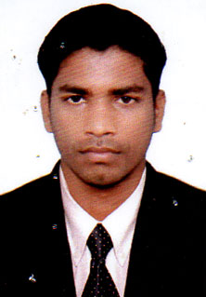

**Arun Jacky**

Present address : Doha - Qatar

Mobile : +974 -33448055

E-Mail : arunjacky105@gmail.com

**Profile**

Looking for a challenging position as a driver with messenger in an organization with more than **15 years total exp** as 05 years in India and 02 years in Saudi Arabia and 07 year in Qatar.

**Experience:**

* Al Fuad Oil Filed company : 3 years
* Limousine : 5 years

**Personal information:**

* Nationality : India
* Date of birth : 10.05.1989
* Gender : male
* Marital status : married
* LICENSE : Qatar LICENCE (Manual)

**Educational qualification**

* Successfully completed Driving Ordinary Level examination in India and Saudi Arabia

**Skills**

* Good communication
* Interpersonal skills
* Adaptability
* Time management

**Language known:**

* English , Arabic , Malayalam ,
* Tamil – Native Language

I declare that all the information stated above is true to the best of my knowledge and belief.

**……………………**

**ARUN JACKY**