**CURRICULUM VITAE**

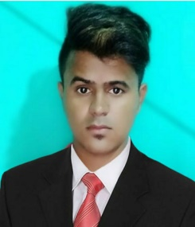

**MD SAZZAD KHAN**

**Present Address:**

Al Bustan Ajman

Near Zym Bullding Ajman {uae}

Mob:0562019750 ***E-mail: khansazzad1123@gmail.com***

**Career Objective :**

To work in a stimulating environment where I can apply & enhance my knowledge, skill to serve

the firm to the best of my efforts. I wantto make my mark in the elite of company. I am seeking

quality environment where my knowledge can be enriched. I am a good worker believe in hard work. To make a carrier in such a leading organization and give our best effort in the growth of the organization.

**ACADEMIC QUALIFICATION:**

* Matriculation (10th) From B.S.E.B.(Board) PATNA
* intermediateFrom (12th) B.S.E.B. (Board) PATNA
* Diploma computer Application **(DCA) 06 Months.**

**DIPLOMA COURCE:**

* One year industrial Safety Management &Environment

Al- kabir polytechnic, Jamshedpur

**ORGANISATIONAL EXPERIENCE:**

* **I have three year Experince stoking and sales in supermarket**
* **I have one year for cashier Experience**
* **I have six month food and Beverage Delivery**

**PERSONAL DETAILS:**

Date of Birth : 26/04/1998

Father’s name : Mr. MD SAMSUZZOHA

Gender : Male

Languages known : English , Hindi & Urdu Arbaic

Nationality : Indian

Marital status : Unmarried

I have 3No ; uae driving licence

Passport No : P1268504,

Passport Stuts : ECNR

**DECLARATION**

“I do hereby declare that the information given above is true to best of my knowledge &belief”.

PlaceYour sincerely

Date: **(MD SAZZAD KHAN)**