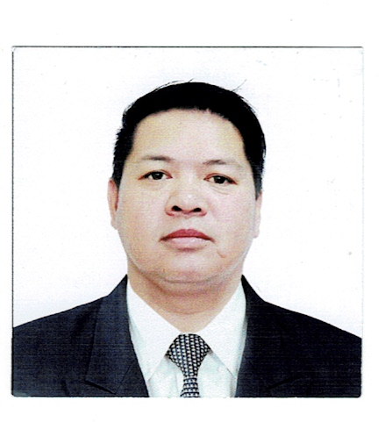**ALDAN URGUELLES DURAN**

3921 yague st.Bgy.sta cruz city of makati .Philippines

Cell No. +639064645639

Cell No. +97470834080

Present add: Ezdan 32 villa 100 al wukair doha qatar

Email Add: [aldan_duran@yahoo.com](mailto:aldan_duran@yahoo.com)

Email Add: ad09061970@gmail.com

Position: VIP Driver ___________________________________________________________________________________

**OBJECTIVE**

To work in a company where I can maximize and exercise my full potential and enable me to grow learn more in pursuing a career.

**PROFESSIONAL EXPERIENCE**

**Challenger rent a car**

**30 Ocr.2022 up to present**

**Ezdan 32 villa 100 al wukair Doha Qatar**

**VIP Driver**

**1Aviation Cebu Pacific**

**15 FEB 2022 up to nov 11 2022**

**Terminal 4 Cebu Pacific Bldg.**

**Equipment operator**

**TOYOTA ABDULLAH ABDULGHANI BROS.**

July 15, 2007- July 30, 2018

P.O. BOX 1321 DOHA, QATAR

*Tourist and Limousine Driver*

**JOB DESCRIPTION**

* Act as tourist guide, used to drive hotel guest to some other tourist spot and historical places.
* Act as front liner in hotel client handling.
* Serves and assist VIP's and hotel foreign/local guest.
* Assure hotel's guest administration, security, comfortable travel guest assistance.
* Records all details of transaction between guest and vehicle for further reference.
* Ensure guest safe travel from pick-up to airport going to hotel, vice versa and also to other destination.
* Maintain cleanliness of vehicle, interior and exterior.
* Maintain and *always* check the good condition of vehicle.

**TRAINING AND SEMINARS ATTENDED**

* QATAR GAS Safely Driving Trainee – 2015
* Qatar International Driving Center – 2016
* Toyota Abdul Abdulghani Customer Service Training Program – 2017

**US EMBASSY PHILIPPINES**

(2004-2007)

ROXAS BLVD.MANILA, PHILIPPINES

*Diplomat Driver*

**AUSTRALIAN EMBASSY PHILIPPINES**

(2002-2003)

RCBC MAKATI CITY, PHILIPPINES

*Diplomat Driver*

**DOLLAR RENT A CAR**

(2000-2002)

NEWWORLD HOTEL MAKATI CITY, PHILIPPINES

*Limousine Driver*

**EDUCATIONAL ATTAINMENT**

**ELEMENTARY** Francisco Benites IV Elementary School

(1979-1984)

**SECONDARY** Pateros Municipal High School

(1984-1988)

**SPECIAL SKILLS**

* Manage to work under pressure with minimum supervision
* Able to communicate well, both in Filipino and English
* Can deal with people at all levels or at all walks of life
* .Equipment oprator
* .Forklift operator

**PERSONAL INFORMATION**

Age 52years old

Gender Male

Status Married

Height 5'6

Hobbies Eating and Playing basket ball and table tennis