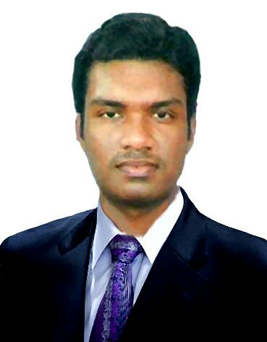**M.l.SADAM HUSSAIN**

**+97470967425**

[**Safa1291@gmail.com**](mailto:Safa1291@gmail.com)

**Doha, Qatar**

**OBJECTIVE:**

To excel in the field of auto mobile engineering with professionally managed and customers oriented company by managing multiple task efficiently.

**EDUCATION DETAILS:**

Completed Diploma in **Auto Mobile Engineering** (2012) in M.A.R Polytechnic College Recognized by Anna University in Tamil Nadu.

**WORK EXPERIENCE: TOTAL (10 YEARS)**

**(Doha Qatar)**

**Organization :** **Semco Cars & Equipment Center (Garage)**

**Tenure:**  January 2022 - untill

**Designation:** **Supervisor,Job Card Controller,Spare Parts In Charge**

**(Doha Qatar)**

**Organization :** **Victory Car Maintance(AVIS Garage)**

**Tenure:**  August 2020 – December 2021

**Designation:** **Supervisor,Job Card Controller,Spare Parts In Charge**

**(Doha Qatar)**

**Organization:** **Msheireb Auto Services(Garage)**

**Tenure:**  May 2018 – July 2020

**Designation:** **Supervisor,Quality Control ,Team Leader**

**(Brunei)**

**Organization:** **De Remba Spares Center**

**Tenure:**  August 2016 – January 2018

**Designation:** **Store Keeper**



**(Tamil Nadu,INDIA)**

**Organization:** **Bawa Honda Bike Showroom[India]**

**Tenure:**  September 2015 to July 2016.

**Designation:** **Spare Parts Incharge/Store Keeper**

# Job Responsibilities:

* Ensure safe keeping both as to quality and quantity of materials. Also maintain proper records.
* Initiate action for stoppage of further purchasing when the stock level approaches the maximum limit.
* Check and receive purchased materials forwarded by the receiving department and to arrange for the storage in appropriate places.

**Dubai(UAE)**

**Organization:** **Upgrade Auto Services**

**Tenure:**  November 2013 to June 2015

**Designation:** **Floor Incharge,Supervisor**

# Job Responsibilities:

* Confer with customers to obtain descriptions of vehicle problems and to discuss work to be performed.
* Estimate costs and time required for repair or maintenance of the vehicle.
* Repair, maintain and service vehicles and their mechanical and electronic components.
* Maintain records of repair and service work, and make reports to detect recurrent faults.
* Make sure the vehicle is returned to the owner in a clean and decent state.
* Provide information for staff about latest developments, technical specifications of new cars, garage merchandise, etc.

**Tamil Nadu (India)**

**Organization:** **Hyundai Motors Pvt Ltd[India]**

**Tenure:**  April 2012 to July 2013

**Designation:** **Quality Control,Panel Checking**

# ADDITIONAL COURSE:

* Hardware and Networking (SSI Computer Education, Mayiladuthurai – India)

# TECHNICAL SKILLS:

* Tools - Microsoft office 2010, Photoshop CS3.
* Operating System - Windows XP, Windows 7, Windows 8.

# PERSONAL DETAILS:

Date of Birth : 31-12-1991

Gender : Male

Marital status : Single

Languages known : English, Malay and Tamil

Nationality : Indian

Passport No. : K1665949

# DECLARATION:

I there by declare that the information furnished above is true to the best of my knowledge.

**M.I.SADAM HUSSAIN**