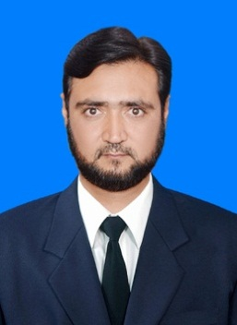

**F A R H A D – A L I**

***Postal Address***

*Bilal colony near HIT gate no 5 house 100/2 Taxila Cantt*

*Tehsil Taxila District Rawalpindi*

*Mohalla Ayub Khel, Village & Post Office Zaida, District & Tehsil Swabi,*

*Cell:* ***+92-315-5131606***

*Email:* [farhada80@gmail.com](mailto:farhada80@gmail.com)

## **Objective**

*To enhance and develop the ability of working in a competitive environment where I could have the opportunity to work enthusiastically for the attainment of organization goals and objectives as regards OSH.*

## **EXPERIENCE**

* **AutoCAD Operator** **in** Mimar Consultants SWABI Branch from **2005** to Jul **2009 (2D & 3D Civil work feet in inches experts)**
* **1** Years’ Experience in **Interior Designer.**
* **AutoCAD Draftsman** in KSA **(Saudi Binladin Group R P D**) from May **2010** to June **2017.**
* **I Still work in PTC ( Pakistan Tobacco Company ) in Akorha Kutak (Group of BAT) As AutoCAD Senior 3D Mechanical & ( Civil 3D ) Designer up to date.**

## **certificate**

* **Board of Intermediate and Secondary Education Peshawar**

S.S.C (Mathematics, Physics, Chemistry, Biology).

* **OSHA** from (**USA 48 Hours**).**IOSH** from (**UK**).
* **One Years Certificate in OSH (PAKISTAN TTB KPK Peshawar).**
* **NEBOSH.** (IGC 1 - IGC 2) ( **Result in the pipe line)**

## **Other – ABBILITIEs**

* **G-II level** 24 month **Certificate holder** in **Civil Drafting** from (Trade Testing Board Peshawar).
* One year diploma in **Interior Designing,** duration of six + six month semesters from (skill development council Peshawar).

## **Other – Skills**

* Computing , Reporting , Driving ,

## **Languages**

Excellent communication and written skills in ,**Urdu,** and **Pashto.**

## **Personal information**

Father’s Name Zarshaid Ali

Nationality Pakistani

Domicile Swabi (KPK)

Religion Islam

Marital Status Married

D.O.B 04-01-1980

CNIC 16202-0925986-7

Passport No. BC1799863

Passport EXP 25-JAN-2024