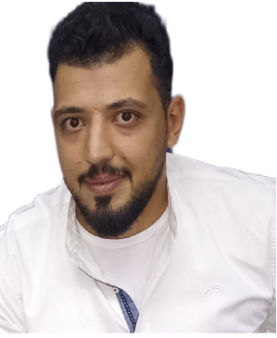

**Asi adel**

Doha , Qatar | +974 39955218

adabneh12@gmail.com | [www.linkedin.com/in/asi-adel](http://www.linkedin.com/in/asi-adel)

**Professional Summary**

An Electrician Superintendent with around 5 years of experience in the field, holder of a Diploma degree in Electrical power systems and have attended multiple courses in the industry. I also gained valuable practical experience in the fields of cables, construction and mega projects. Successfully built a strong presence working within groups

**Professional strengths include:**

* Site Engineering
* Construction Works
* Shop Drawings
* Steel Structure
* Team Supervision
* Reporting
* AutoCAD
* Plc.

# Business Experience

**National Electric Power Company -** *Amman, Jordan*

***Electricity transmission line technician* 02/2022 – Present**

* - I climb high pressure towers and do a general inspection Marketed services of Entrepreneurs & Small Businesses through word-of-mouth and social media accounts
* Making connections for connectors
* Implementation of tower construction projects
* Reading horoscope charts of different types
* Carrying out periodic maintenance of the towers body

**National Electric Power Company -** *Amman, Jordan*

***Electrical technician trainer* 03/2019 -09/2022**

* I trained university students specializing in electrical engineering on the basics of electricity in homes
* I gave a course on medium voltage cables on how to make connections of all kinds
* I gave his turn to climb the high-pressure towers 132/400 kv

- I gave a role in the maintenance of motors and the connection of motors with the relay system and operation by plc. systems

**Asi adel -** *Amman, Jordan*

***Freelancer* 08/2016 – 11/2018**

* I supervised the construction work for several different houses

- I managed the implementation of the plans, including the reinforcement works, concrete works, and electrical installations

# Education

**Diploma in electrical power systems 06/2017**

# Al- Balqa' Applied University (BAU) – *Amman, Jordan*

# Certifications

**House wiring inspection –** **National Electric Power Company (NIPCO) 02/2019**

**Occupational safety – National Electric Power Company (NIPCO) 02/2020**

**Climbing towers - National Electric Power Company (NIPCO) 05/2019**

# Languages

**Arabic:** Native

**English:** Full Professional Proficiency