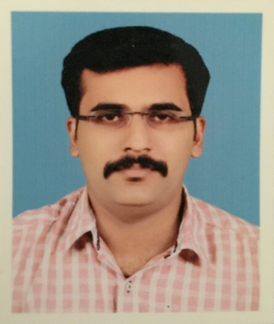  Contact  manishvdanny@gmail.com  Phone:+974 33997596  Date of Birth: 23/May/1989  Marital Status: Married  Nationality: Indian  Passport No: V8371270 | MANISH V DANNY  CAD TECHNICIAN with total of 8 years experience & more than 6+ years GCC experience.
OBJECTIVE

Intend to build a career with leading corporate of hi-tech environment with committed & dedicated people, which will help me to explore myself fully and realize my potential. Willing to work as a key player in challenging & creative environment.

QATAR DRIVING LICENSE (Automatic)

- Valid still 10/01/2028

ACADEMIC RECORD

- Diploma in Civil Engineering (3YEAR)
Director of Technical Education (DOTA), Tamil Nadu, India
- B.tech civil engineering (on going).kerala ,india

- AutoCAD 3D, AutoCAD 2D, 3DSMAX
CADD Centre Training Services, Pathanamthitta, Kerala, India.

LINGUISTIC ABILITIES  English  - Speaking  - Writing  - Reading  Malayalam  - Speaking  - Writing  - Reading  Tamil  - Speaking  Hindi  - Speaking  - Reading | EXPERIENCE  Quality Based Structures WLL, Qatar  August 2017 – Present  - Development of commercial road to Wakrah main road-package 5 Wakrah stadium associated temporary road work.  - Development of Roads & Infrastructure in Rawdat Abal Heeran  - Roads & infrastructure for government residential division in south of Wukair p01-p04 (interim measures-p07-p10).  - Roads & infrastructure in al ebb & leabaib package 04  - Roads & infrastructure in north of mall of qatar area & celebration road, package 02  - External works for ras abu aboud stadium & precincts  - External works for lusail stadium & precincts  - Construction of site 24 lusail bus depot  - Roads & infrastructure in umm slal mohammed phase 2, package 01  - Resign and build of phase one of permanent location of darb al saai  - FIFA readiness project for surface & groundwater network at al thumama frp-c851/3a  - Flood prevention scheme network at al thumama FPS  - Roads & infrastructure in al froosh /al kharaitiyat, package 1  - Gec-Doha west-Dw044 roads & infrastructure in al mearad and southwest of muaither  - construction of remaining works of C2017123, infrastructure fs gaps for bani hajer and alrayyan stadium, foul sewer- package 02 (DN 117-P02).  Reform builders,india  June 2013 – August 2017
WORK SKILLS

- Preparing shop drawings
- Asbuilt drawings
- Progress drawings
- Prepare asbuilt cad drawings for handing-over of Drainage O&M GIS section as per the requirements
- Survey data
- Planning progress drawings
- HSE drawings
- Sketch drawings
COMPUTER SKILL

- AUTOCAD (2D&3D)
- MS Office
- 3DS MAX Photoshop
- Multimedia & Internet
REFERENCES | Nishindas Vipinan  Quality Based Structures WLL  GIS Speciaist  Phone: 55233940

Declaration

I hereby declare that the information furnished above is true to the best of my knowledge and belief.

MANISH V DANNY

