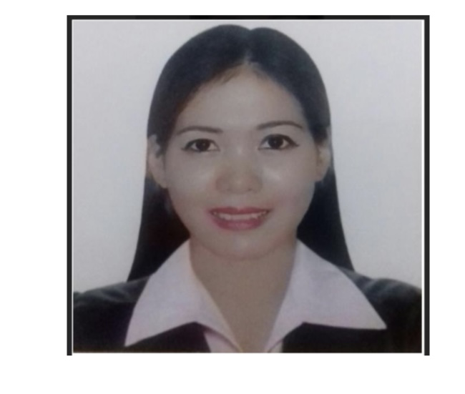

|  |  |  |
| --- | --- | --- |
|  | JANICE PABIGAYAN  Contact # 50116028  Wathsapp #33253837  Pabigayan_janice18@yahoo.com |  |

|  |  |
| --- | --- |
|  |  |
|  | Objective To use my skills in the best possible way for achieving the company goals. |
| T : | PERSONAL DATA Date of birth : 01/18/92  Place of birth : Albano st cauayan city  Civil status: SINGLE  Nationality : pilipino  Language : tagalog English  SKILLS :    Honest  Good communication  Hard working  Committed  Team work  Time management |
|  |
|  |
| EXPERIENCE  LAND MARK GROUP  October 5 2015 to april 10 2019  QATAR  ECCO  HEAD -CASHIER  -  DUTIES RESPONSIBILITY  Greet to customer  Consult wth customer to understand their needs and product  Product knowleged  Preference related to merchandized  Demonstrates and explain  Selecting and suggesting  Option suitable  Customer needs  Manage transaction wth customer using registered  Scan good and ensure pricing  Collect payments weather cash or creadit  Redeem stamp coupons  **ALSHAYA H.M COMPANY**  **Duties & responsibility**  **Welcoming & greetings customer**  **Introduce the I tem**  **What benefit for the customer**  **Explaning to the customer**  **Assist them**  **Team work**  **Manage the customer complainng**  **Counter selling**  **Flexible**  **Loyal**  **Knowledge skill** |
|  | EDUCATIONAL: CAUAYAN SOUTH CENTRAL SCHOOL 1998-2004  CAUAYAN NATIONAL HIGH SCHOOL 2004-2008  ISABELA STATE UNIVERSITY CAUAYAN CAMPUS |
|  |  |
|  |  |