**ABDUL RAHMAN ABDUL JALIL**

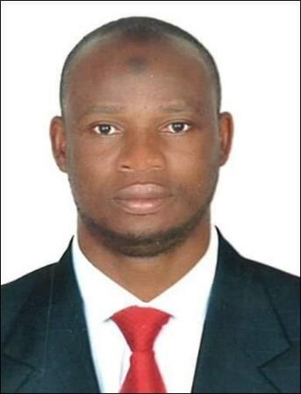

**Phone: 00233594969839/ WhatsApp**

**Email: nurudeenkuberke@gmail.com**

**House no. Ex 13, Jengbeyiri, Wa, Upper West Region, Ghana.**

**SUMMARY**

I have over ten years’ experience driving light vehicles (including 3ton light vehicles) in Ghana, Qatar, Bahrain, and the UAE, with a clean driving record. I also have a record of good behaviour and hard work, which has helped the various companies maximise profit. I have Ghana, Qatar, Bahrain, and UAE licences.

I possess excellent English proficiency and excellent communication skills. (Comprehension, Reading, Speaking, Listening, and Writing). My stay in three different Gulf countries has equipped me with knowledge of the Arabic language and a sound understanding of Arabic culture. I also worked with colleagues of Indian, Bangladeshi, Pakistan, Nepal, Filipino, and African origins, and these experiences are a great asset, which I think can help me fit well in your company by relating well with other co-workers of your company and the customers of the company. This will help increase productivity and help the company maximise profit.

I am seeking a position in your highly regarded company as a light vehicle driver. I shall uphold your company’s commitment to reliability and punctuality.

**Work Experience**

**TAXI DRIVER – Emirate Transport Company – UAE**

**(2018 up to 2022)**

* Picking up a cab from garages before the start of shift and check fuel levels and proper

functioning of brakes and controls

* Helping passengers load and unload their baggage and assisting with luggage, groceries,

wheelchairs, and walkers.

* Abiding by regulations regarding taxi operation and ensuring the safety and security of

passengers.

* Coordinated with dispatchers, customer service representatives, office personnel and

customers.

**Company driver – Al Baraka Facility Hospital – Bharain**

**(2015 – 2017)**

* Safe delivery of hospital equipment and drugs.
* Routine vehicle checks on vehicle to ensure safety and efficiency.
* Cleaning of the vehicle before and after the day’s work.
* Taking my boss and other hospital staff to places for official duties.

**TAXI DRIVER – Mowasalat Trasnport Company – Qatar**

**(2013- 2015)**

* Picking up and delivering customers
* Taking the fastest and safest route

* Helping to load and unload the vehicle
* Calculating the right fare and returning the correct change

* Keeping vehicle clean at all times

**Education**

School: Wa Islamic Senior Secondary School

(2004 – 2007)

SKILLS AND KNOWLEDGE

* The ability to communicate with passengers in a respectful manner and to make passengers comfortable.
* The ability to read maps to be able to navigate the road networks and to send passengers and equipment to their various destinations.
* Problem solving skills: drivers must be able to make quick decisions concerning route changes in the event of closed roads, construction, and/or heavy traffic and resolve passenger complaints
* The ability to fix vehicles minor problems especially when there is a breakdown.
* Ability to provide top-notch customer service with a friendly attitude.
* Ability to conduct routine vehicle checks to ensure safety and efficiency.
* Ability to drive all forms of light vehicles including 3ton light vehicle
* Clean driving record in Ghana, Qatar, Bahrain and the UAE.
* Possessed customer-focused mindset.
* Ability to work independently and collaboratively.

**KNOWLEDGE**