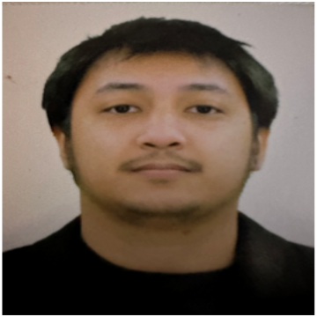 |  | JOHN PAUL MARCAIDA
Profile  Innovative, loyal and hard-working with a strong commitment in delivering top quality technical services. A quick learner who is passionate in achieving the best technical support.  Career objectives  To obtain a challenging position with a progressive company where my work experience will have valuable application and utilization of opportunity in advancement. I would like to render my knowledge and expertise.  Contact  PHONE:  +97471675496  EMAIL:  jpcmarcaida@gmail.com  Hobbies  Watching comedy and substance movies  Playing basketball  Contact references  Rogie Lopez Kolimlim  Operations Manager |  | EDUCATION  AMA Computer College East Rizal  Bachelor of Science in Information Technology  2019-2021  Techonological Institute of the Philippines  Bachelor of Science in Mechanical Engineering  2017-2019  College of San Benildo Rizal  2011-2015  WORK EXPERIENCES  Admin Supervisor  Jopam Waterproofing  November, 2021-2023  Duties and Responsibilities:  - Supervision on communication procedures, guidelines, and policies of the company  - Promoting company’s profile and bidding project  - Processing clients’ complaints and requests.  - Handling phone calls for billing, inquiry, etc.  - Attending client’s meeting  - Supervision on Company’s Projects applying sealants, coatings and other materials to surfaces in order to prevent water from penetrating and causing damage  SKILLS  Time management  Problem resolution  Communications  Microsoft Word  Microsoft Excel  Quick learner  Multi- tasking  Dependable and reliable  Creative problem solving  I hereby certify that all the information stated herein is true to the best of my knowledge.  JOHN PAUL C. MARCAIDA

