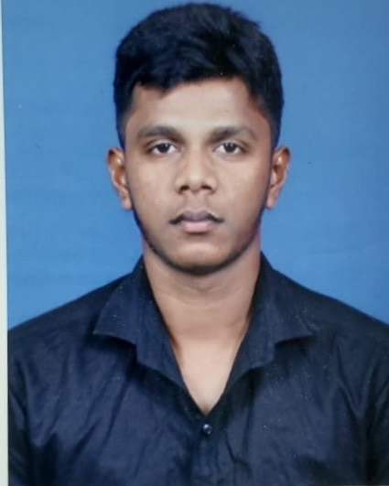

**JILAKSHAN PERINPAM MOHANADAS**

Mobile No: +974 30587309

Email: [gilakshan2013@gmail.com](mailto:gilakshan2013@gmail.com)

Doha Qatar.

**PROFILE**

Experienced and reliable Driver with vast experience working in the transportation

Of goods and passengers. Adept in safe driving practices and traffic laws. Bringing

Forth a clean driving record as well as a career history full of satisfied customers and clients. Experienced in performing maintenance and minor repairs on vehicles.

Committed to the safety and successful transportation of goods, passengers, and vehicles

**SKILLS :**

Navigation, Problem solving, Empathetic, Efficiency, Safety, Detail - oriented and dispatch

**Personal Details:**

Name : Jilakshan Perinpam Mohanadas

Date of Birth : 29/05/1994

Gender : Male

Nationality : Sri Lanka

Marital Status : Single

Present Address : Doha Qatar

QID No. : 29414403738

Expiry Date : 26/04/2023

Visa Status : Work Visa

**Educational Qualification**:

* O Level
* A Level

**Language**:

* English, Arabic, Hindi, Tamil

**Passport Details:**

Passport No. : N7390068

Date of Issue : 03/04/2018

Date of Expiry : 03/04/2028

Place of Issue : Sri Lanka.

**License Details**:

Type of License : Qatar Light Driving License

License No. : 29414403738

Validity : 2026 - 03 - 24

Place of Issue : Qatar

**Work Experience**:

**COMPANY DRIVER / BACKGROUND CONTRACTING CO. -2014 - 2019**

Drives an automobile to transport staff and equipment. Arranges to pick up staff or groups on a schedule. Communicates with manager by telephone to exchange information and receive request for staff service .

* Ensure that staff arrived safely and timely to their destination

* Manage routes through the use of iphone application technology

**Limousine Driver**

**LIMOUSINE Company 2019 - 2021**

* Communicated with passengers and transported them to and from their desired destinations, ensuring the great customer experience.

* Maintained vehicle clean and in excellent condition, provided all -time excellent customer service, and resolve any customer problematic issues.

* Loaded and unloaded vehicles, identified and took the shortest and fastest root, and demonstrated the ability to remain calm in stressful situation.

* Followed navigational directions from GPS, calculated the right fare, and executed multiple administrative tasks as required

* Achieved and maintained a perfect 5 - star uber rider rating.

**DELIVERY DRIVER**

**ARAMEX DOHA WLL 2021 Present**

* Operated vans under 3 tons to transport products to an average of 90 customers per day with 0 acidents

* Verified the contents of inventory loads against shipping papers, maintaining vehicle logs and cargo records

* Managed loading and unloading truck, maintaining a 93% package integrity rating

**Decleration:**

I hereby declare that the above particulars are true and correct to the best of my knowledge.