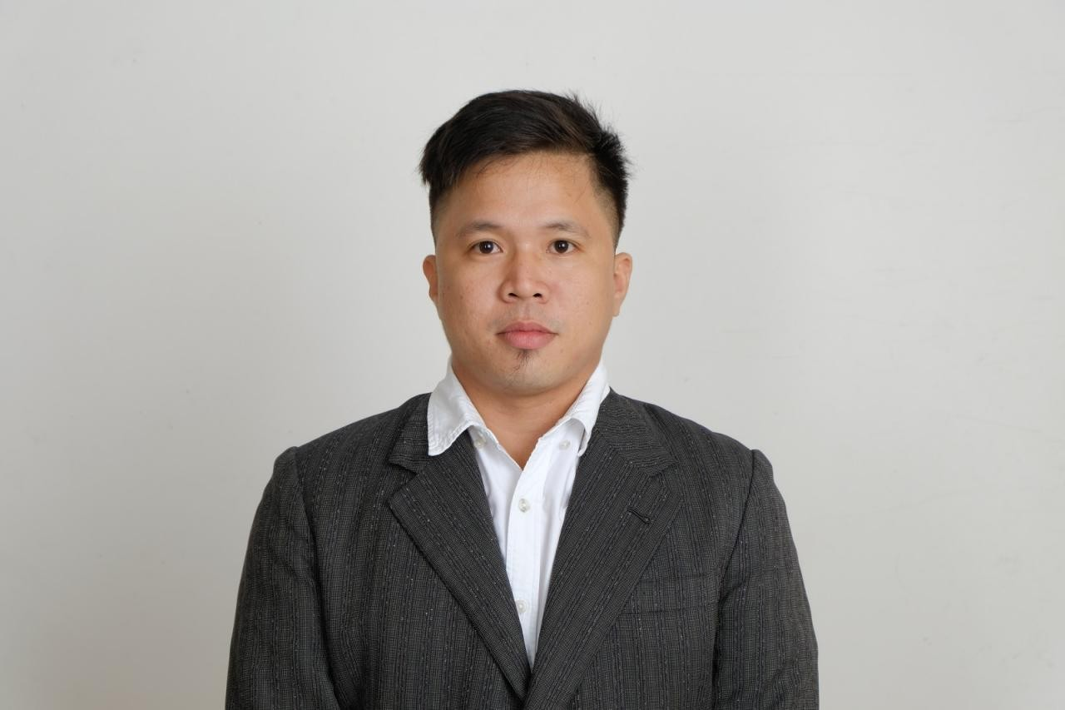

ILIAS C. BALOPIÑOS

Purok 2, San Jose, Cebu City Cebu Philippines

(+63) 9150370889

[iliasbalopinos@gmail.com](mailto:iliasbalopinos@gmail.com)

# OBJECTIVE

To join an organization where I can use my skills and expertise in electromechanical field and attain a high level of performance in all aspects.

# EXPERIENCE

**DYNAMIC POWER MARINE AND INDUSTRIAL HARDWARE INC.**

JANUARY 8, 2015 – JANUARY 15,2018 POSITION: ELECTRICIAN

WORK FUNCTIONS:

* Assemble generator sets, marine and industrial generator(weichai, deutz, baodouin, ricardo british stamford, magnaplus,).
* Load bank testing and commissioning generator sets.
* Wiring Installation and testing electrical system of marine engine, power steering and marine transmission.
* Testing synchronize generator sets and re program control module ( deep sea electronics and harsen).
* Troubleshoot and rewiring generator set electrical control system.
* Pre delivery inspection and aftersales support . **Fil GENERATORS AND SERVICES COMPANY** MARCH 6, 2018 – JAN.32021,

POSITION: GENERATOR TECHNICIAN WORK FUNCTIONS:

* Load testing and commissioning generator sets (cummins, perkins, yangdong).
* Trouble shoot and check up generator sets such as (cummins, perkins, denyo, mitsubishi, caterpillar, deutz.
* Rehab and wiring of generator electrical control system, Retapping of alternator from 3phase to 1phase, from 220Vac to 440Vac output.
* Conduct Preventive Maintenance Services and change oil and filters of generator sets.
* Load bank testing and re program con module such as ( deep sea electronics , harsen and smartgen).
* Installation and check up of automatic transfer switch.
* Basic knowledge in troubleshoot mechanical problem of generator set, tune up and overhaul engine.
* Welding and ducting of generator exhaust . **PRIME POWER ENERGIE SYSTEM INC.** MARCH JANUARY 8,2021 – UP TO PRESENT

POSITION: TESTING AND COMMISSIONING SUPPORT/AFTERSALES SUPPORT WORK FUNCTIONS:

* testing and commissioning generator sets (cummins, mitsubishi,mtu)
* Pre start up pre commissioning checklist up all gensets before start up.
* Conduct actual and online orientation of the gensets personnel.
* Conduct Preventive Maintenance Services and change oil and filters of generator sets.
* Configure genset controllers such as (deepsea,harsen,smargen)
* Installation and check up of automatic transfer switch.
* Basic knowledge in troubleshoot mechanical problem of generator set, tune up and overhaul engine.
* Assist testing and commissioning of (LVSG,MVSG,SYNCH PANEL,TRANSFOMERS).

# EDUCATION

**TERTIARY ATTAINMENT**

# CENTER FOR INDUSTRIAL TECHNOLOGY AND ENTERPRISE

BRGY. SAN JOSE, CEBU CITY

COURSE: ELECTROMECHANICAL TECHNOLOGY

# SECONDARY ATTAINMENT

**VALENCIA NATIONAL TECHNICAL VOCATIONAL HIGH SCHOOL**

VALENCIA BOHOL S.Y 2010-2011

# REFERENCES:

* MR. ANTONIO ANCAJAS

Aftersales coordinator in Dynamic power marine and industrial hardware inc. 09177226166

MR. JOHNNY ZAMORA

Technical supervisor in Fil generators and Services Company 09171404243

MR. JULIUS TAGAPAN

Project incharge in Prime Power Energie System Inc. 0909064042031