## 

## 

## CURRICULUM VITAE

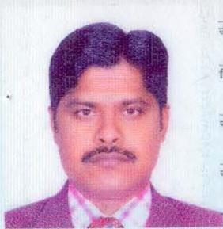

**Vittal Mamula**

India

Mobile: +91 9440655005

Email: [mamullavittal@gmail.com](mailto:mamullavittal@gmail.com)

## Objective

## 

To obtain the post of **Heavy Driver** to contribute and seek challenge in dynamic origination to work in a professional environment that offers growth and learning opportunities based on my qualification and experience.

Dedicated and dependable as Bus Driver with excellent record of company satisfaction. Stickler for punctuality and safety. Established history of completing driving jobs through various kinds of territory at various lengths.

**Driving License:**

* Valid Qatar Heavy vehicle License.
* Kuwait heavy Vehicle license Expired.

**Gulf Total Work Experience: 14 Years**

**From Dec 2017 to March 2019**

Working as a **Heavy Bus Driver** in CMTC. Doha, Qatar.

**From December 2012 to July 2017**

Working as a **Heavy Bus Driver** in Effeco Electro & Mechanical Co. Doha, Qatar.

##### From October 2010 to October 2012

Worked as a **Heavy Driver** in Sodexho Company Kuwait.

##### From January 2009 to July 2010

Worked as **Heavy Bus Driver** in Arabtec Constructions Co (W.L.L) Doha-Qatar.

##### From 2005 to 2008

Worked as a **Heavy Bus Driver** in Sagar transport Company Kuwait.

**Core Qualifications**

* Thorough knowledge of automobile and equipment safety
* Ability to work long shifts up to around the clock
* High flexibility in scheduling including nights weekends and holidays
* Excellent driving ability even in poor weather conditions
* Good availability for assignments on short notice
* Good problem-solving and analytical skills
* Operated buses on a variety of scheduled routes
* Drove bus for mail run when required
* Identified operational and mechanical issues and reported same to garage technical crew

**Personal Details:**

Name : Vittal Mamula.

Date of Birth : Feb 02nd 1985.

Marital Status : Married

Passport Number : M 3807354

Nationality : Indian

Place of Issue : Doha, Qatar

Date of Issue : 17.12.2014

Date of Expiry : 16.12.2024

Current Address : H.NO.5-49, Village: Vannal, MDL: Nandipet,

Dist: Nizmabad, T.G. India

Languages Known :English, Arabic, Hindi & Telugu

### Educational qualifications : SSC

**DECLARATION**

I hereby declare that above said are true to the best of my knowledge and believe to be true.

Thanking You,

Vittal Mamula