**SYED SHAUKAT ABBAS KAZMI**

**CHIEF WARRANT OFFICER (Rtd)**

**QA/QC/SAFETY OFFICER/ELECTRICAL ENGG**

**CONTACT:**

**Phone:** +923202550499

**WhatsApp:** +923202550499

**Email:** [shoukatkazmi77@gmail.com](mailto:shoukatkazmi77@gmail.com)

**CAREER OBJECTIVE:**

Seeking QA/QC/Safety Officer and Electrical Engg Position in an organization where I can utilize my skills and be an asset to the employer.

**EDUCATION:**

* MA (EPM)
* MA (POLITICAL SCIENCE)
* B TECH (ELECTRICAL)
* DAE (ELECTRICAL)

**EXPERIENCE:**

**PAKISTAN AIR FORCE**

* QC/ Safety Officer.
* Quality Assurance.
* Ground Safety Officer.
* Associate Engineer (Elect).
* Maintenance of MT Vehicles, Power Generators & Air Cond Plant.
* UAV Maintenance / Inspection.
* GSO & Quality Inspector (AGE).
* Office, HR, GSO, Quality Control & Safety Inspector (R & D).

**ACHIEVEMENT:**

* CAS Commendation Certificates.
* (03) Base Commander Commendation.
* (03) ACAS Tech Commendation.
* (04) CAS Blood Donor Commendation.

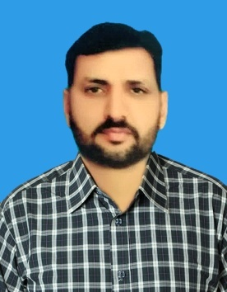

**CERTIFICATE:**

* QC / QA Program.
* Quality Control.
* Safety Inspector.
* Fire Prevention & Safety Officer Course (For Educational Institute)
* Fire Prevention Officer.
* Fire Prevention & Safety Officer Course (For Oil Installations)
* Fire Safety Officer Management Course
* SEP Management Supervisory Course
* Military Leadership & Command
* Maintenance Supervisory Course.
* Ops, Maint & Troubleshooting of Millat Generators Electrical Course.
* ASC-500 Mobile AC Plant Fam Course.
* Ops & Maint of CCTV Cameras.
* F-7P & FT-7P A/C Fam Course.
* UAV TRC (Electomech).
* UAV Burraq Course.
* Simulators Ops /Maint C-130 A/C.
* X-TMC F-7P A/C Electromech course.
* Electromech Citation XL A/C Course.
* Air Defense Generators & Man Truck.
* Aeromedical Simulators Ops & Maint.
* Ops and Maint on TEREX Crane.
* Teaching Techniques Course.
* AD GEN & MEN Truck (Elect Sys).
* Anza Weapon System Ops and Maint.

**EXPERTISE:**

* Safety.
* Communication.
* Research.
* Multi-Tasking.
* QA/QC.
* Office Assistant (HR).
* Maintenance of MT, Generators & HVAC.
* Engineering, Technical and Administrative Supervision.

**REFERENCE:**

References will be provided when required.