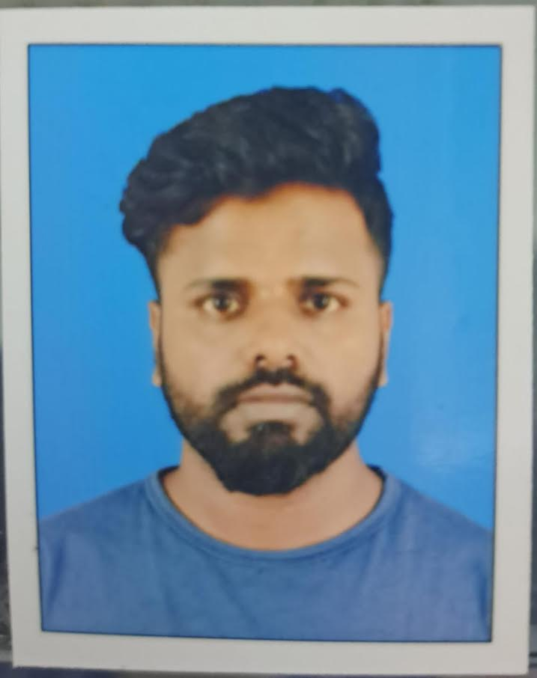  Email:  YAZARARAFATH186@gmail.com  Contact:  +97471764291  Address for communication:  AL WAKRAH, Qatar  Personal Data:  Age: 30 years  Date of Birth: 18 - JUNE - 1993  Sex: Male  Marital Status: MARRIED  Father’s Name: MOHAMMED YUSUF  Nationality: Indian  Visa Status: NOC (With transferable)  Passport No: W4606926  Date of Expire: 17/12/2025  Languages Known:  - English (Read, Write & Speak)  - Tamil (Read, Write & Speak)  - Hindi (Speak)  - Malayalam (Speak)  Software Skills:  - MS OFFICE  - DRIVING LICENCE  - Qatar | SUMMARY  I possess 5 years of experience in the store keeper cum driver Provided proactive support to internal and external customers for office and working site facilities  EDUCATION:  - SREE KRISHNA POLYTECHNIC COLLEGE, NAGERCOIL  - Diploma in computer engineering.  - XII– ST. MARY’S HIGHER SECONDARY SCHOOL  - Tamil Nadu, India, 2010.  - X– GOVT HIGHER SECONDARY SCHOOL  - Tamil Nadu, India, 2008.  PROFESSIONAL EXPERIENCE:  Company: HIGH TECH SUPERMARKET  - Experience: May 2020 to May 2023  Role: STORES KEEPER,Driver  Company: GULF SUPERMARKET  - Experience: Nov 2015 to March 2021  Role: STORES KEEPER,Driver  DUTIES & RESPONSIBILITIES Receive and forward all types of goods and deliveries in and out of the hotel to the correct point of storage area.  - Follow all standards for issuing and receiving stock within the store's area of operation.  - Monitor and take inventory on regular basis to compile orders based on par levels or needs.  - Maintain clear and organized records to ensure all reports and invoices are filed and stored properly.  - Monitor Periodic Automatic Replacement levels for all food items to ensure proper levels.  - Responsible to verify all goods arrived as per the agreed purchase, delivery note and agreed quantity has been received.  - Responsible for storage of both food & beverage and operational stock.  - Responsible for the day to day check on the storage facilities of upkeep and hygiene.  - Refuse acceptance of damaged, unacceptable, or incorrect items.  - Ensure cleanliness of all areas, keeping storage areas clean & tidy and in strict compliance with hygiene regulations.  - Ensure all store requisitions are signed by concerned Department Heads (HOD’s) and approved by FC/GM depending upon the hotel's operations procedure.  - Ensure the quantity requested and the quantity issued always matches.  - Ensure store requisition form is signed by the person collecting the goods and enter into the Inventory/Materials Management System.  - Post all invoices using the MMS - Material Management System.  - Speak with others using clear and professional language.  - Follow up on documentation of after-hours issues ensuring it is in accordance with established internal controls and procedures.  - Adhere to all Health and Safety procedures particularly relating to food and beverage items.  - Conduct inventory audits to determine inventory levels and needs  DECLARATION  I hereby declare that the above-mentioned data are true to the best of my knowledge.  MOHAMMED YASAR ARABATH M

