CURRICULUM VITAE

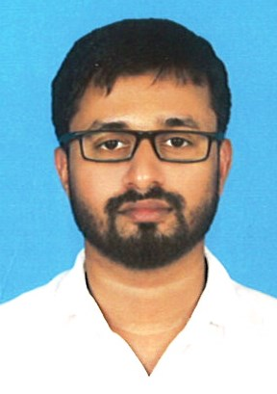

MUHAMMED RASHID PUL PARAMBIL
Mobile-+974 -77098493
E-mail:rashidpullaloor786@gmail.com

CAREER OBJECTIVE:
Seeking a position in an organization to boost my career and provide organizational and goal
Oriented skills to the benefit of the company.

ACADEMIC QUALIFICATION:
- S.S.L.C Secondary School Public Examination Kerala,India
- +2 Higher Secondary School Indian Education Board
SUMMARY OF SKILLS
- Comprehensive problem solving abilities, excellent verbal and written communication skills, ability to deal with people diplomatically.
- Empathetic
- To inspire and to support team leadership
- Ability to handle pressure in stressful situations.
- Flexibility to work in shift
LANGUAGE PROFICIENCY
- English- Read, Write and speak.
- Arabic-Speak
- Malayalam - Read, Write and speak.
- Hindi speak

LICENSE DETAILS
- License No : 29135607446
- License Type : Qatar light driving license.
- License Issue : 11/09/2013
- License Issue : 10/09/2023

Working Experience
- 6 Years working experience as Driver at Doha-Qatar
- 01 Year Working experience as Sales Man at Doha-Qatar
PERSONAL PROFILE:
Name : MUHAMMED RASHID PUL PARAMBIL
Address : Doha – Qatar
QID no : 29135607446
Date of Birth : 02/02/1991
Nationality : Indian
Marital status : Married
Passport No : M9520428
Validity : 28/05/2025

REFERENCES:
As for me I am a hard working and dedicated employee and I hope that my application will find your due consideration and provide me with an opportunity with a favorable reply at the earliest convenience. Other references can be provided on request.

DECLARATION:
I hereby put forward my candidature for your kind consideration with the declaration that the above mentioned factors are correct and true to the best of my knowledge and belief.

Place:
Date:
MUHAMMED RASHID PUL PARAMBIL

