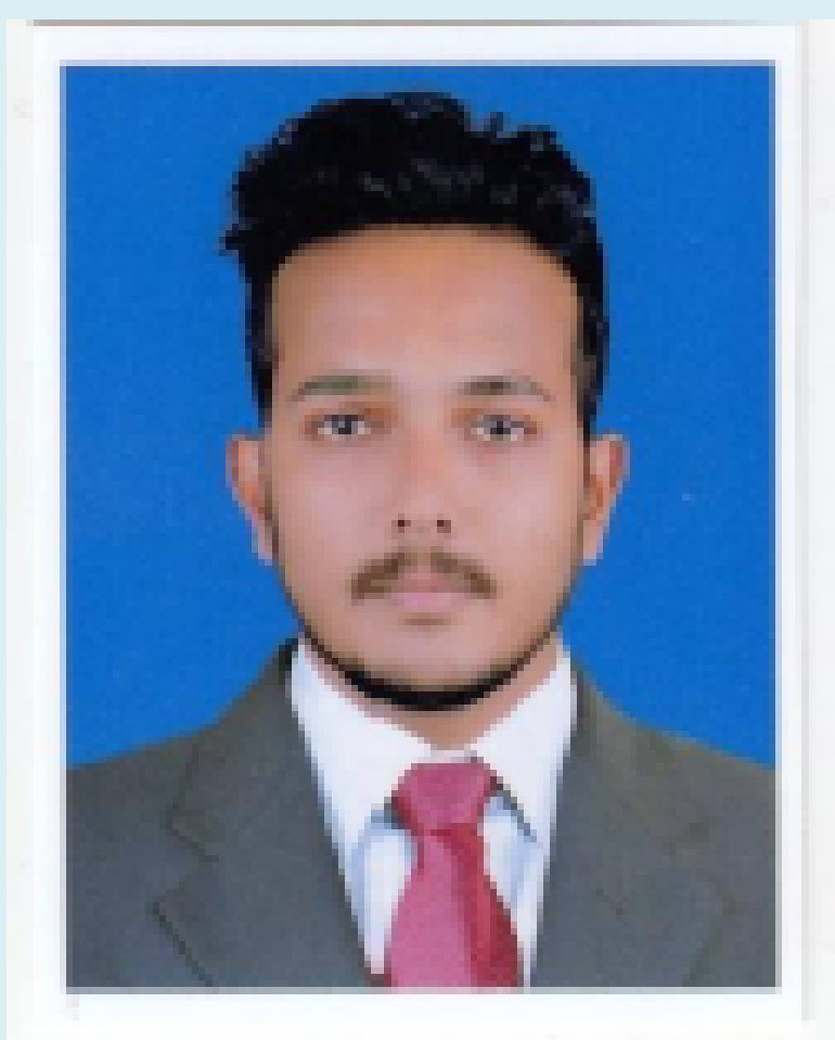

**MUHAMMED HAKIMSHA**

Contact: +974 31234116

Email: hakimshahakku@gmail.com

CAREER VISION

As an AutoCAD Draftsman, my objective is to contribute to the company’s success by producing the most accurate and feasible illustrations for the projects assigned to me. **My Experience of more than 5 years as an Auto Cad Draftsman** **in Architectural Environments** broadened my knowledge and enhanced my skills in creating and modifying drawings using the latest technologies. I am eager to learn and further my proficiencies by constantly improving my work and accepting all kinds of assignments handed out to me. I am confident that I can measure up to the expectations of the company.

PROFESSIONAL QUALIFICATION

* **DIPLOMA IN CIVIL ENGINEERING**

(Board of Technical Education, NCVT Govt of India)

And All India Technical Education Society (AICT)

TECHNICAL QUALIFICATION

* **Diploma in ID Graphix**

Auto CAD 2d & 3ds Max - (Cad Centre Trissur Kerala, India.)

* **Micro Soft Applications: MS Word & MS Excel**
* **Adobe Photoshop.**

PROFESSIONAL EXPERIENCE

1. **THAJ CONSTRUCTIONS**

Chentrappini Trissur Kerala India

**Designation:** Architectural Draftsman & Site Supervisor

(Since - July 2018 to August 2019)

* **Project Details**
* **Residential Villas And Commercial Buildings**

Chentrappini Trissur Kerala India

* **Responsibilities**
* Prepare detailed architectural drawings for residential and commercial construction projects.
* Create architectural drawings based on building specifications, calculations and sketches
* Visit construction sites to collect measurements and dimensions as needed.
* Analyze building specifications, codes, space to create architectural design.

1. **CREO CONSTRUCTION EXPERTS**

Pazhuvil Trissur Kerala India

**Designation:** Architectural Draftsman & Site Supervisor

(Since - January 2020 to April 2022)

* **Project Details**
* **Residential Villas And Commercial Buildings**

**Renovation Villas and Interior Works.**

**Landscaping and Irrigation**

Thrissur Kerala India

* **Responsibilities**
* Prepare detailed architectural drawings for residential and commercial construction projects.
* Create architectural drawings based on building specifications, calculations and sketches
* Visit construction sites to collect measurements and dimensions as needed.
* Analyze building specifications, codes, space to create architectural design.
* And Prepare Detail Drawings. Wet Area And Dry Area

1. **CAPO TRADING AND CONTRACTING W.L.L**

Doha Qatar

**Designation:** Architectural Draftsman & Site Supervisor

(Since - may 2022 to )

* **Project Details**
* **Residential Villas And Commercial Buildings**

**Installation of natural stones - Wall cladding**

**Marble flooring**

**Hardscape installation**

Doha Qatar

* **Responsibilities**
* Prepare detailed architectural drawings for residential and commercial construction projects.
* Create architectural drawings based on building specifications, calculations and sketches
* Visit construction sites to collect measurements and dimensions as needed.
* Analyze building specifications, codes, space to create architectural design.
* And Prepare Detail Drawings. Wet Area And Dry Area

**PERSONAL DETAILS**

**NATIONALITY** : Indian

**MARITIAL STATUS** : Single

S**EX** : Male

**DATE OF BIRTH** : 29.9.1997

**RELIGION** : Muslim

**LANGAUGES** : English, Hindi, Malayalam, Tamil

**PASSPORT No.** : T3124803

**PASSPORT VALIDITY** : 03/02/2029

**QATAR ID No.** : 29735623375

**EMAIL** : hakimshahakku@gmail.com

**VISA STATUS** : Employment (Transferable)

**DECLARATION**

I assure that the above-furnished details are true to the best of my knowledge and belief. If I am given a suitable opportunity in your organization, I will discharge my duties to your utmost satisfaction.

**MUHAMMED HAKIMSHA**

Doha, Qatar, +974 31234116­­­