GREGORIO M.SERENAS JR.

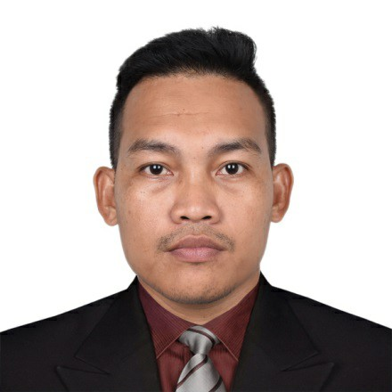

# Address: BLK.66 LOT.11 Northville 8 Bangkal, City of Malolos Bulacan Philippines

Email: annieserenas26@gmail.com

Contact Numbers: 09517222374

## OBJECTIVES

Ambitious and responsible worker, eager and I can utilize my organizational and time-management skills to help better the company. PERSONAL INFORMATION

|  |  |
| --- | --- |
| ● | Nick Name: Gregor/Greg |
| ● | Civil Status: Married |
| ● | Gender: Male |
| ● | Nationality: Filipino |
| ● | Birth Date: May 28 1987 |
| ● | Pace of Birth: Sto. Nino Samar |
| ● | Mother’s Name: Nida M Serenas |
| ● | Father’s Name: Gregorio Serenas Sr. |

EDUCATIONAL ATTAINMENT:

TERTIARY ELECTRO MECHANICSTECHNOLOGY

Dualtech Center Manila

Binondo, Manila

2011-2013

# SECONDARY PAYATAS HIGH SCHOOL

Molave St. Payatas B. Quezon City 2003-2006

# PRIMARY PAYATAS B. ELEMENTARY SCHOOL

Upper Nara St. Payatas Quezon City 1998-2003

TRAININGS& SEMINARS HILTI PHILIPPINESINC.

2326 Pasong Tamo Ext. Makati City

August 5, 2011 – February 15, 2013

WORK EXPERIENCE

# GLI CONSTRUCTION SERVICES

Service Center Technician ( Factional Expertise)

*Small Engine

*All kinds of Power Tools

*Grass Cutter

*Pressure Washer

*Gragarage Equipment

* Installer ( Two Post Car Lifter)

* Basic Electrical

*Basic Welding

Milagrosa Calamba City

2023 - Present

WUERTH PHILIPPINES INC.

Hydraulic Technician and

Power Tool Technician (Factional Expertise)

*Neumatic Impact wrench

*Neumatic Grease Dispenser

*Two Post Car Lifter

*Demolition Hammer

*Combination Hammer

*Rotary Hammer *Coring Machine

Technopark Laguna

2021-2022

# NEHMEH MAKITA

Power toolsTechnician (Factional Expertise)

*Jig Saw

*Orbital Sander

*Coring Machine *Rotary Hammer

*Demolition Hammer

*Cordless Drill

*Magnetic Drill

Doha Qatar

2014 – 2016

# HUSQVARNA PHILIPPINES

Power ToolsTechnician Specialist

*Coring Machine

*Cutting Machine

9004 Katipunan Avenue Loyola Heights, Quezon City 2013 – 2014

HILTI PHILIPPINES INC.

Power Tools Technician and Repair Specialist

*Jig Saw

*Orbital Sander

*Coring Machine *Rotary Hammer

*Demolition Hammer

Pasong Tamo Ext. Makati City

August – 2011 – August - 2013 PRIMAPLASTICCORPORATION

Machine Operator

First Industrial Malolos Bulacan 2009 - 2010

FUNASIAINC.

Machine Operator (Molding Injection)

Mapulang Lupa Valenzuela City

2007 - 2008

## CHARACTER REFERENCE

MR. EFRENTERENAL AMS MANAGER

HILTI PHILIPPINES +63917 887 8245

MR. ROMMEL GUINTO

PROFESSOR / MENTOR

DUALTECH MANILA BRANCH +63920 982 5164

MR. JASONOBANANA REPAIR TECHNICIAN

HILTI QATAR +63942 193 7249

MR. JUNEL CACAL

OWNER / HUSQVARNA DISTRIBUTER

CUT & BREAK CONSTRUCTION

+63922 241 0841

I hereby certify that the above information is true and correct.

____________________

Gregorio M. Serenas Jr.