

ASIF MUSTHAFA



Doha, Qatar •+97450410641 • [ashi0696@gmail.com](mailto:ashi0696@gmail.com)

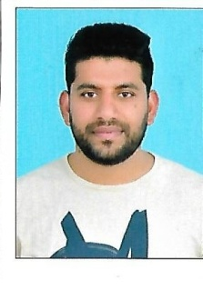

Messanger Cum Driver



Objective

## To work in a firm with a professional work driven environment where I can utilize and apply my knowledge and skills which would enable me to enrich my career while fulfilling organizational objective



Work Experience

**Company Name: - Water Treatment System (WATS)**

**Duration: - June 2015 – February 2018.**

**Company Name: - UNITED CONSULTANTS (A-Grade Consultants)**

**Duration: - April 2013 – June 2015for 3 Yr’s.**

 

**Company Name: - Al - Naser Bin Khalid**

**Duration: August 2008 - April 2013.**



Skills

# Personal Skills

# Good communication skills.

* Logical approach to problem solving. Team Player.
* Keep up-to-date with technological advances. Aptitude to undertake leadership roles.
* Flexible and adaptable to changes.
* Ability to organize and produce well structured work in Hardware Technology
* microsoft office word,excel,power point,outlook etc.



Certifications

Academic Education: Passed Secondary School-2002

Govt: Higher Secondary School)

Vadanappilly-Kerala-INDIA

Technical Education : Passed Diploma in Diesel Mechanic(1-Yr)

2003(Al-Noor Technical College-Industrial

Training Centre – Vatanappally-Kreala-INDIA







**My Word**

I hereby declare that the above written particulars are true to the best of my knowledge and belief**.**

Yours sincerely**,**

**Place : Doha.**

**Date : 27/08/2017 ASHIF MUSTHAFA**

Thank you for using [www.freepdfconvert.com](http://www.freepdfconvert.com/) service!

Only two pages are converted. Please Sign Up to convert all pages. <https://www.freepdfconvert.com/membership>