**Mohammed Baseer Uddin** 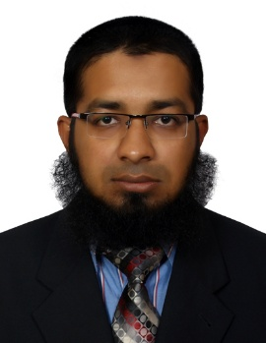

**Mobile: +917680990272 (IMO&WHATSAPP)**

E-mail id: [baseeruddin123@gmail.com](mailto:baseeruddin123@gmail.com)

skype id: baseeruddin7

IMO & WHATSAPP NUMBER : **+917680990272**

**Career Objective:**

To be in a challenging position where I can use my technical skills coupled with people skill to build a team driven by value and performance, enhance my knowledge and skills and be an assets towards the organization.

**Professional Experience:**



**ORGANISATION:**

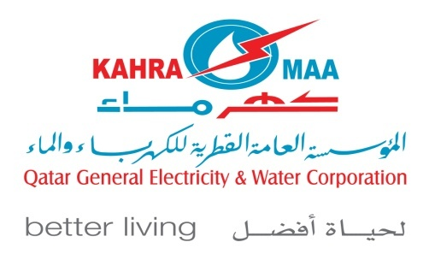**Rashid Bin Hussain Rashid Trading & Contracting Co** established in 2007 as trading and contracting Co. The remarkable and encouraging market response and enormous good will the venture started growing. The company has various ranges of activities. Civil contracting, trading, transporting, manpower etc. are prominent among them. **Rashid Bin Hussain Rashid Trading & Contracting Company is the Main Contractor of ‘KAHRAMAA’ in Electrical & Civil Department.**

**Work as Civil and Electrical Draftsman ( Approved from kahrama )**

From JUNE 2021 to AUGUST 2023

**COMPLETED CONTRACTS:**

CONTRACT : GTC-837/2016 (DISTRIBUTION CABLE FAULT LOCATION (L.V& M.V) REPAIR ROUND THE CLOCK)

**Working Contracts :**

GTC-996/2020 (DISTRIBUTION CABLE FAULT LOCATION (L.V & M.V) REPAIR ROUND THE CLOCK)

GTC-918/2018 LOT-2 (11 KV REINFORCEMENT WORKS)

GTC-931/2019 (MAIN EXTENSION OF LV U/G NETWORK SERVICE

CONNECTIONS

GTC-939/2020 LOT-1 & LOT-2 (LV REINFORCEMENT & EMERGENCY (MV) CABLE FAULT REPAIR)

**Example** : To show the cable sizes, Joints, Shutdown and Jointing Date & Jointer name with his License number and all details.

To prepare as-built drawing of the cable laid at the site.

Making trance drawings for cool length cable.

To submit as-built drawing in KAHRAMAA GIS department

**Work as Draftsman**

**Freelance** from 2019 to 2020

**Work as** : Shop Drawings, As Built Drawing , Working Drawings , Section Drawings , Layout Drawing , Interior Drawings, and Elevation Drawings.

➢Preparing as built drawings.

➢Visiting site to take necessary dimensions and prepare drawing as per site

**MS Construction , Hyderabad, (INDIA)**

Worked as a Auto Cad Draftsman for From February 2018 To November 2018

Responsible for following duties and services:

**Work as** : Shop Drawings, As Built Drawing , Working Drawings , Section Drawings , Layout Drawing , Interior Drawings, and Elevation Drawings.

➢Preparing as built drawings.

➢Visiting site to take necessary dimensions and prepare drawing as per site

**Saudi Ceramic, Riyadh, (KSA)**

Worked as a Auto Cad Draftsman and Equipment Inspector from December 2015 to December 2017

**Responsible for following duties and services:**

**Work as :** ShopDrawings, As Built Drawing , Working Drawings , Section Drawings , Layout Drawing , Interior Drawings**,** andElevation Drawings**.**

**Sing marble Art international Dubai UAE**

Worked as a Auto Cad Draftsman from August 2014 to may 2015

**Responsible for following duties and services:**

**Work as :** ShopDrawings, As Built Drawing , Working Drawings , Section Drawings , Layout Drawing , Interior Drawings**,** andElevation Drawings**.**

* Preparing as built drawings.
* Visiting site to take necessary dimensions and prepare drawing as per site.

**JUAM ASSOCIATES ARCHITECT & ENGINEERS.**

Worked as a Auto Cad Draftsman from January 2011 to May 2014 (3.5 years).

**Responsible for following duties and services:**

**Work as :** ShopDrawings, As Built Drawings , Working Drawings , Presentation Drawings , Section Drawings , Electrical Drawings, Layout Drawing , Interior Drawings**,** andElevation Drawings**.**

* Preparing as built drawings.
* Visiting site to take necessary dimensions and prepare drawing as per site.

**PROJECTS:**

Project Name:  **SHARJAH MILITARY HOSPITAL .** (**Sharjah**)

Project Name: **THE BINARY.** (**Dubai**)

Project Name: **JUMEIRAH GOLF ESTATES VILLAS. (Dubai)**

Project Name: **GENERAL WOMEN’S UNION MUSEUM-.** ( **Abu Dhabi** )

Project Name: **The Pointe**  **palm Jumeirah -.** ( **Dubai** )

Project Name: J**ean Samman Villa Jumeirah -.** ( **Dubai** )

Project Name: **United Arcade Commercial Complex ( India )**

Project Name: **Masaba Habitat Residential Complex** **( India )**

Project Name: **Symphony Villas. ( India )**

Project Name: **Apple Hospitals.** **( India )**

Project Name: **Y.S Shopping Mall. ( India )**

Project Name: **Agriculture Art Exhibition For Tourism Department Govt of AP. ( India )**

Project Name: **Sara Homes Residential Complex. ( India )**

**ACADEMIC QUALIFICATION:**

Diploma in Auto Cad 2D and 3D from Indo British Academy Hyderabad.

Diploma in Civil Draftsman from Indo British Academy Hyderabad.

Diploma in Revit from Indo British Academy Hyderabad.

Board of Secondary from Nizam Boys Town High School.

Board of Intermediate

**PROFESSIONAL SKILLS:**

**Auto- cad:** Version 2000, 2006, 2007, 2009, 2010, 2011, 2014,2015,2019,2020,2022

**Revit :** Version 2009, 2010,2014, 2015

**Computer knowledge:** Ms Office, Excel

**PERSONAL INFORMATION**

Father’s Name : Mohammed Asif Uddin

Languages known : Hindi, Urdu , English and basic Arabic

Marital Status : Married

Covid-19 vaccinated : Moderna Both Doses

Nationality : Indian

Religion : Muslim

Date of Birth : 16-08-1988

Passport no : S1966269

Driving license no : DLFAP012167172006

Current address : Hyderabad ,Telangana state (India)

I hereby confirm that the information given above is true to the best of my knowledge and belief.

**(Mohammed Baseer Uddin).**