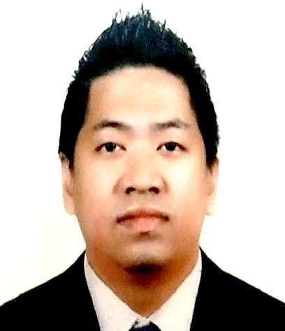 **BRYAN R. EVORA**

 **:** TAYUMAN SITIO MAILIW LOBO BATANGAS PHILIPPINES

 :09361933837

 **:** bryanevora83@gmail.com



**PERSONAL BACKGROUND**

**NAME** : Bryan R. Evora

**AGE :** 40 yrs old

**PLACE OF BIRTH :** Poblacion San Teodoro Oriental Mindoro

**DATE OF BIRTH :** May 08, 1983

**CITIZENSHIP :** Filipino

**CIVIL STATUS :** Married

**RELIGION :** Roman Catholic

**Height** : 5’6

**SEX :** Male

**WEIGHT :** 80 kgs

**DIALECT SPOKEN :** Tagalog/English/Arabic

–

**EDUCATIONAL BACKGROUND**

**COLLAGE**  : **Organic Agriculture Production NC11**

**YEAR**  : Nov 17,2023 to Dec 29,2023

: **Vocational Course - RTC TESDA**

**COLLAGE** : **FILIPINO COMPUTER LITERACY PROGRAM NIIT-JEDDAH K.S.A**

: **Computer Hardware Servicing**

: Windows Server and Networking Basic

**OPERATING SYSTEM** : Windows Xp, Windows 8, Windows 10

**UTILITIES**  : MS-Office, MS-Word, PowerPoint Etc

**YEAR**  : 24 April 2015 to 4 Sept 2015

**SECONDARY** :  **San Teodoro National High School**

: SY-1999-2001

**PRIMARY**  : **San Teodoro National Central School**

: SY- 1996-1997

**WORK EXPERIENCES**

**COMPANY : PASCAL RESOURCES ENERGY INC.**

**ADDRESS :** Barangay San Isidro, Lubao, Pampanga

**POSITION : Account Development Specialist**

**EMPLOYMENT DATE**   **:** June 29, 2022 to November 15,2023

**COMPANY : ZAINAL ELECTRONICS CENTER**

**ADDRESS :** Industrial Area57 Street 44 Gate 50 P.O. Box 10657 Doha Qatar **POSITION : Sales Merchandiser**

**EMPLOYMENT DATE**   **:** April 2, 2019 to April 2, 2021

**COMPANY : LANDMARK ARABIA CENTERPOINT**

**ADDRESS :** Amil Sultan Street Jeddah K.S.A

**POSITION : Senior Sales Associate**

**EMPLOYMENT DATE :** Feb 23, 2008 to Sep 5, 2018

**COMPANY : Fortune M. Trading Inc.**

**ADDRESS :** #4034 San Francisco Bulacan

**POSITION :** Product Consultant

**EMPLOYMENT DATE :** December 20, 2005 to December 15, 2007

**COMPANY : Promote INC.**

**ADDRESS**  : #Unit 5b 3/f Manican blg 9802 Kamagong cor, Makati

**POSITION**  : Promo Merchandiser

**EMPLOYMENT DATE**  : November 8, 2004 to July 25, 2005

I hereby certify that the above information is true and correct to the best of my knowledge**.**

**BRYAN R. EVORA**

Applicant