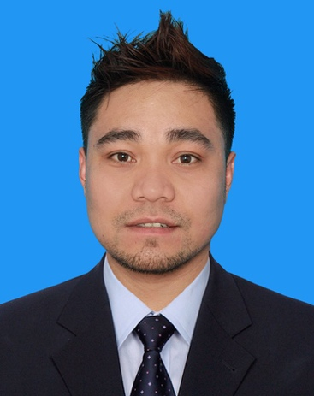

JEROME SALVINO VIEJO
Mobile # : +974 3328 2289
Email Address: jirum23@yahoo.com

WORK EXPERIENCES
Position Merchandiser
Company Nestle Qatar Trading/Brandaid
Address Doha, Qatar
Employment Date Dec. 2016 to Oct. 2022
Key Responsibilities
- Implement Nestle products according to the company planogram.
- Build and maintain relationships with appropriate customers in all accounts.
- Communicate with customers during service calls and respond to customer requests.
- Follow operational standard procedures that outline route schedules merchandising principles, rotating products regularly according to expiry, and front-facing product.
- Ordering and reporting out of stock products.

Position Merchandiser
Company Ali Bin Ali (Procter & Gamble)
Address Doha, Qatar
Employment Date August 02, 2015 to November 2016
Key Responsibilities

- Keeping in contact with existing customers in person
- Monitors expiry. FIFO procedure
- Oversees deliveries and displaying the items
- Ordering and Reporting out of stocks
- Planogram and Implementation

Position SUPERVISOR
Company MAF Carrefour Hypermarket Address Doha, Qatar
Employment Date June 02, 2010 to January 22, 2015
Key Responsibilities
- Keeping in contact with existing customers in person.
- Distributing tasks and duties
- Monitors expiry of fresh products. FIFO procedure
- Oversees deliveries and displaying the items
- Ordering and dealing with the suppliers.
- Planogram and Implementation
- Warehouse arrangement
- Supervising Inventory / Stock take of warehouse and selling area

Position WAREHOUSEMAN
Company SM Supermarket (main warehouse)
Address Paranaque City, Philippines
Employment Date February to July 2008
Key Responsibilities
- Unloads inventory from trucks.
- Helps ship merchandise to retail stores and other outlets.
- Checks item labels whether they are drawn correctly.
- Performs inventory on a regular basis.
- Puts merchandise on their proper shelves.

Position NURSING ASSISTANT
Company Ospital ng Palawan (Provincial Hospital)
Address Puerto Princesa City, Palawan, Philippines
Employment Date May 2006 to February 2007
Key Responsibilities
- Measure vital signs like blood pressure and temperature.
- Turn, reposition and move patients between wheelchairs, seats and beds.
- Maintain patients’ hygiene and change bedding.
- Serve meals and help patients eat their food.
- Help patients use the bathroom.
- Assists patients to the radiology area.
- Insert catheter and IV

EDUCATIONAL BACKGROUND
Vocational GEFI Community College
Address Puerto Princesa City, Philippines
Course Healthcare/ Nursing Assistant
Year Attended 2005- 2006

College Fullbright College
Address Puerto Princesa City, Philippines
Course Bachelor of Science in Education
Year Attended June- September 2004 (First Semester)

Secondary Bagong Sikat National High School
Address Bagong Sikat, Narra, Philippines
Year Attended 2000- 2004

Primary Bagong Sikat Adventist Elementary School
Address Bagong Sikat, Narra, Palawan, Philippines
Year Attended 1994- 2000

PERSONAL INFORMATION

Birthdate January 28, 1987

Place of Birth Ilocos Sur, Philippines

Civil Status Single

Nationality Filipino

Religion Christian

Languages English and Pilipino
Passport P1008660B

I hereby certify that the above information is true and correct to the best of my knowledge and belief.

JEROME SALVINO VIEJO

