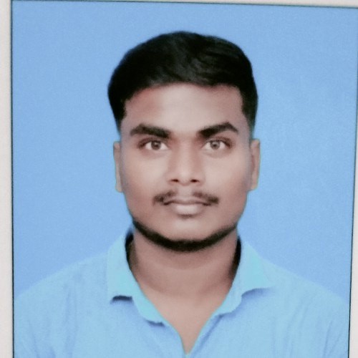 Doha- Qatar.  31617023

 [kesavanelumalai1998@gmail.com](mailto:kesavanelumalai1998@gmail.com)

•Dedicated and experienced Supervisor cum Driver with a proven track record of

effectively managing teams and ensuring timely and safe transportation. Seeking to utilize my skills and expertise in a dynamic organization that values professionalism and excellence.

Valid Qatar car driving license (manual) Valid Indian Batch License

2014- 2015

2016-2017

2017 -2018

2017 - 2020

2022 - 2024

2021 - 2022

2020 - 2021



SSLC

Higher secondary school Land and survey Engineer BBA

Distance Educational

PICK QUICK LIMOUSINES

* Supervise a team of drivers, ensuring

adherence to schedules and safety regulation's•

* Coordinate daily transportation activities to meet customer needs and organizations•
* Conduct pre-trip and post-trip vehicle inspections to ensure roadworthiness•
* Maintain accurate records of vehicle maintenance, fuel consumption, and driver logs•
* Provide excellent customer service and address any issues or concerns promptly•



*PICK QUICK LIMOUSINES*

*Safely operated various vehicles to transport passengers or goods to designated locations.

*Followed traffic laws and regulations to ensure passenger safety and on-time deliveries.

* Assisted with loading and unloading of cargo, ensuring proper handling and secure transportation.
* Maintained cleanliness and orderliness of food to present a professional image to customers.

Doha - Qatar.



*TALABAT*

Knowledge of safety regulations and best practices•

* + Ability to multitask and prioritize tasks effectively•
  + Proficient in vehicle maintenance and repair basics•

Ability to lift and carry heavy food orders and operate a vehicle for prolonged periods of time•

Strong interpersonal skills, including verbal communication and conflict resolution Mindset for organization and attentions•

Doha- Qatar•

2018 - 2019



*Naksatra construction*

Working as surveyor on site orientated• Detail, Physical Stamina•

Total station and chain survey oriented• Time management skills, Visualization skills• Tamilnadan - India •

MS- EXCEL MS-WORD

Strong leadership and communication skills. Excellent driving record with a valid driver's license•

Surfing through internet

Tamil English Hindi



Full Name : Kesavan Elumalai QID Number 29835611185

Passport number: T880444 DOB : 21/0/1998

Gender : Male Marital status : single Country : India

I hereby declare that all the information given above is true and correct to the best of my knowledge.

**KESAVAN ELUMALAI**