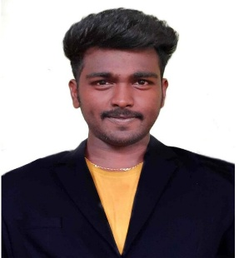
RESUME
Email: jambukasrinivas@gmail.com
JAMBUKA SRINIVAS, whatsapp: +918712298980
Mobile No: 97451142311
Objective:
To take up a challenging Career grows with honesty, loyalty, Good relationship and best performance, and translate my Experience and abilities into value for an Organization.
Experience:
- 3 years experience as a Marketing – Sales Executive, sri jayalaxmi Hyundai automotive industry, Hyderabad 2021 January to 2024February.
- 6 months experience as a Admin assistant in positive health science, Hyderabad, India in 2020 June to 2020 December
Qualifications:

Qualification School/College University/Board Aggregate Year of
% Passing
Degree  BBA | NSV Degree College  Jagityal | Shathavahana University | 86.9% | 2020
Intermediate  (ET) | Sankalpa vocational  Junior college,  Metpally | Board of Intermediate  Telangana | 89.7% | 2017
SSC | Sri Vasavi High school Metpally, Karimnagar. | State Board of  Secondary Education  Telangana | 73% | 2015

Skills:
- MS office
- MS excel
- MS PowerPoint
Certifications
- Office Administrations-2023 in ICICI Skills academy, Nampally, Hyderabad
- Retail Management-2018 in Pradhan Mantri Kaushal Vikas Yojana,Metpally ➢ PGDCA-2015
Strength:
- Flexible
- Fast learner
- Time management
- Positive attitude
Personal Information:
Name : Jambuka Srinivas
Father’s Name : J Narsaiah
Date of Birth : 12th June 1999
Gender : Male
Nationality : Indian
Languages Known : English, Hindi& Telugu.
Passport details:
Passport number : S0713344 passport validity : 2028-4-12
Visa validity : 2024-05-09
Declaration: I hereby declare that the information furnished above is true to the best of my knowledge and I bear the responsibility for the correctness of the above mentioned particulars.
Date:
Place: (Srinivas Jambuka)

