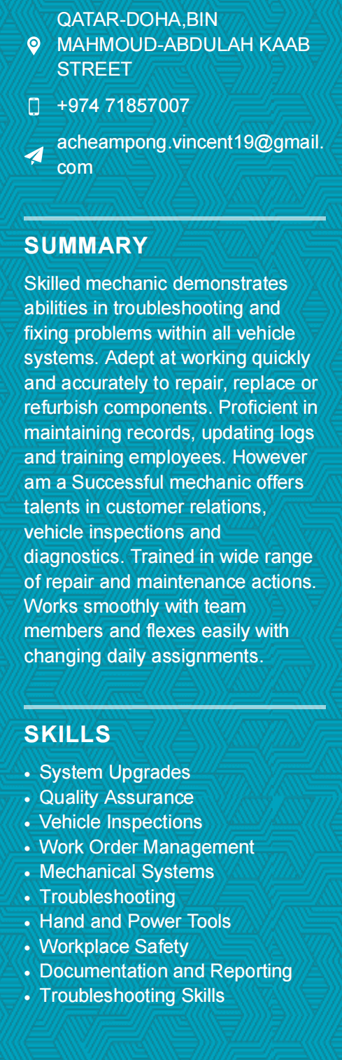 **ACHEAMPONG VINCENT ANTWI**

**WORK EXPEREINCE**

JANUARY 2024 TO DATE

MECHANIC TOPLINE SERVICE CENTER ǀ Suhaim bin hamaf, Doha

**RESPONSIBILITIES:**

● Installed new or rebuilt engines into vehicles following manufacturer's

instructions for installation procedures.

●Planned work procedures using charts, technical manuals and

experience.

●Maintained garage safety protocols to meet regulatory and company

expectations.

●Inspected, serviced, and repaired brakes, exhaust systems,

transmissions, engines, suspension systems, drive trains, fuel systems

and other vehicle components as required.

● Conducted test drives before and after repair services.

Removed old oil, replace filters and added correct amount of new engine oil.

● Repaired, replaced and adjusted brakes.

Organized tools and supplies neatly within the workspace for easy

access during maintenance tasks.

● Completed required paperwork and delivered to customer.

Checked vehicle mileage and determined necessary belts, fluids flushing or gasket replacements.

Explained technical diagnoses and needed repairs to non-mechanical

individuals who lack technical knowledge.

● Monitored shop equipment to maintain safe working condition.

**JANUARY 2022-DECEMBER 2023**

**STOREKEEPER TOYOTA WAREHOUSE | TOYOTA GHANA KUMASI**

**RESPONSIBILITIES:**

● Giving the right parts to customers and delivering on time.

●Managed inventory tracking and physical inventory counts to minimize

loss.

●Preserved product quality by maintaining stockrooms and disposing of

damaged items.

●Tracked expiration dates of stored items to ensure freshness of products

sold in storerooms.

● Tracked, documented and resolved discrepancies on received orders.

Investigated discrepancies between physical count results and

computer-generated reports.

●Performed routine housekeeping tasks such as sweeping floors,

cleaning shelves.

● Updated stock information on a daily basis in the system

**JANUARY 2020-DECEMBER 2021**

**MAINTENANCE PLANNER | TOYOTA WORKSHOP-GHANA**

**RESPONSIBILITIES**

**● Schedules vehicles for preventive maintenance**

**lubrication, repairs, and vehicle assignments for a large repair shop**

**based on request for field repairs,**

**personnel availability, preventive maintenance schedules, and**

**availability of pool vehicles; receives requests for field repairs;**

**maintains equipment repair history folders, lubrication and mileage**

**records, and an equipment assignment file; prepares weekly report of**

**vehicle repair progress; check equipment in and out of the repair**

**facility; dispatches pool equipment; determines need for field repair**

**of equipment; answers questions from the field regarding length of**

**servicing time or vehicle down time due to repair; and may**

**occasionally be assigned to other duties for training purposes or to**

**meet technological changes or emergencies**

**JANUARY 2018-DECEMBER 2019**

**STORE CLECK ASENSO BERVERAGES** | KUMASI , GHANA

**RESPONSIBILITIES:**

● Stocked shelves with incoming shipments of products from vendors or

●Assisted coworkers with special projects to learn new tasks while

gaining additional responsibilities.

●Examined packages and goods for damage and notified vendors of

replacement needs.

●Welcomed customers, offering assistance to help find store items.

●Organized store shelves according to product type and size.

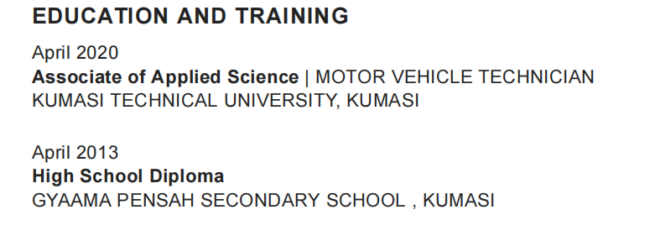

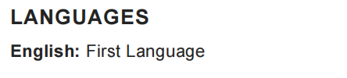

**CERTIFICATIONS**

FORKLIFT LICENSE

DRIVING LICENSE LD