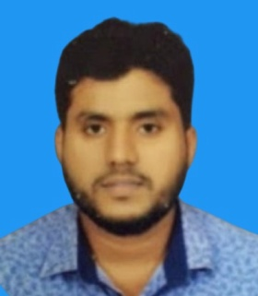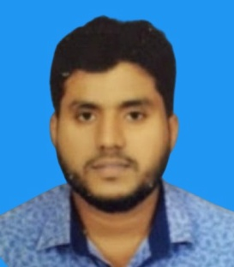ABDUL MAJEED MOHEMED AZEEM

# EDUCATION

**General Certificates of Education**

* Passed Ordinary Level 2001
* Passed Advance Level 2003
* Passed Government approved Al Aalim Certificate Examination (2003)
* Islamic Higher Education Studies (1996-2003) – An Noor Arabic College, Kurunagela, Sri Lanka.
* Successfully completed Diploma in English and Computer Studies

# CONTACT

**Mobile: +974 39974653**

**Email:** [**mazeem841@gmail.com**](mailto:mazeem841@gmail.com) **Doha, Qatar**

# CONTACT

**Mobile : +974 39974653**

[**mazeem841@gmail.com**](mailto:abdulhafeel97@gmail.com)

**Doha , Qatar**

# PROFILE

A well-organized visionary individual with a passion to grow up in the career ladder with the never give up attitude. Passion towards work keeps uncompromised at all Time across all touch points in character. A well- versed team player who could acknowledge and adopt team attributes in achieving common goals.

# OBJECTIVE

To join an organization with highly dedicated and professional work environment and apply my knowledge and skill to achieve challenging goals for the organization to get my future aim.

# PERSONAL DETAILS

**Full Name: ABDUL MAJEED MOHEMED AZEEM**

**Date of Birth 24-03-1984 Passport No – N9336645 Gender - Male**

**Nationality - Sri Lankan MaritalStatus: MARRIED**

# INTERESTS

* Reading
* Travel
* Sports

# DECLARATION

I do hereby declare that the above information given is true and best to my knowledge.

Yours sincerely: Mohemed Azeem  
Mobile: 00974 39974653

**LANGUAGE PROFICIENCY**

Fluent in read, written and spoken Arabic, English, Tamil and Sinhala languages

**VISA TYPE**

* **TRANSFERABLE WITH NOC**

# EDUCATION

General Certificates of Education

Passed Ordinary Level 2001

Passed Advance Level 2003

Passed Government approved Al Aalim Certificate Examination (2003)

Islamic Sharee'ah Studies (1996-2003) – An Noor Arabic College, Kurunagela, Sri Lanka.

Successfully completed Diploma in English and Computer Studies

# PROFESSIONAL QUALIFICATION.

Having Driving License – Qatar

# WORKING EXPERIENCE Working Experience

* 8 years in Kuwait as driver
* 3 years as a messenger in Qatar
* 1 year as salesman in Qatar

**SKILLS**

* Communication
* Organization
* Decision making
* Team Player
* Administration
* Adaptability
* Internet & Email
* Operational Knowledge
* MS Office