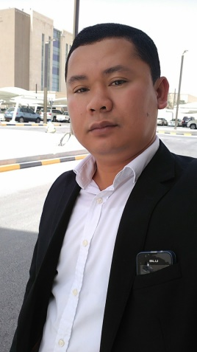

ROLLY A.SEBUAN

Mobile No. : 09489985403

Address: Purok Soledad Brgy.Dulao Bago City
Negros Occidental Philippines
Email: rollysebuan93@gmail.com

OBJECTIVE:
To be part of an organization that would help me utilizes the skills and knowledge that I possess and in return use these in contributing to the success of the organization.

EMPLOYMENT RECORDS:
- Herbanext Laboratories Inc.
- Company Driver/ Messenger
2020 up to Present

- Goldenfield Singcang Bacolod Delivery Driver/Tires& Lubricant oils
- 2019 to 2020

- Power International Holding- Doha, Qatar
Company Driver
2014 May to 2019 June

- RNG. Markiting,Bounty Fresh Chiken Distributor-Bacolod City
Warehouse Man/Driver
2013 to 2014

- International Catering Corp.- Saudi Arabia
Delivery Driver
2011 to 2013

- Philippine Airlines- Manila Base Complex
Building Attendant
1999 to 2011

- Sewing Company- Calamba Laguna
Factory Worker
1997 to 1999

- Had. Yulo- Soledad Dulao Bago City
Farmer
1995 to 1997

EDUCATIONAL BACKGROUND:

- Training/Seminar: Automotive/Driving- January to June 2006

- High School: Ramon Torres National High School Bago City- 1996

- Elementary: Vidal Cauntoy Elem.School Dulao Bago City- 1992

INTERESTS ACTIVITIES AND OTHER SKILLS

- Computer Literate
- Attending Seminars
- Driving
- Playing Basketball

PERSONAL DATA:

- Birth Date : October 08.1977
- Citizenship : Filipino
- Birth Place : Murcia Negros Occidental
- Gender : Male
- Civil Status : Married
- Age : 45 y/o
- Language/Dialect: Ilonggo,Tagalog,English
- Height : 5’6’’
- Driver Lic.No. : No3-10-008244/ Restriction- 1,2,3
- Father Name : Rodrigo Sebuan
- Mother Name : Loda Sebuan

REFERENCES:
Upon Request

I hereby certify that the above information is true and correct to the best of my knowledge and belief.

Rolly A. Sebuan
Applicant Signature

