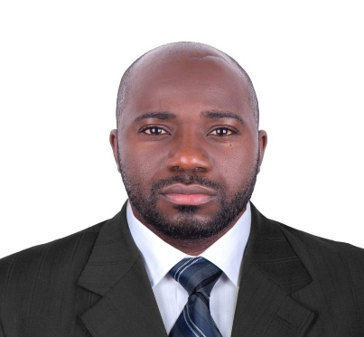

MULONDO FAROUK NAKIBINGE

PROFILE

Am an experienced driver with a proven track record of safe and reliable transportation, ensuring on-time deliveries and exceptional customer service.Am a detail-oriented with expertise in route planning and navigation systems, ensuring efficient and smooth operations.

CONTACT

[Farouqmulondo36@gmail.com](mailto:Farouqmulondo36@gmail.com)

+97455874987

DOHA,QATAR

WORK HISTORY

Americana Food company

2014-2018

Bakemart company

2018-2020

Talabat

2020 to date

Certification

Obtain category B licence

Motorcycle licence

ARCHIEVEMENTS

* Safe driving record with zero accidents or traffic violations in the past nine years.
* Completed over 10,000 miles of long-haul transportation, ensuring on-time deliveries.
* Proficient in using GPS navigation systems to optimize routes and reduce
* travel time.
* Received commendations from customers for exceptional service and professionalism.
* Implemented fuel-efficient driving techniques resulting in a 15% reduction in fue consumption.
* Maintained and inspected vehicles regularly, ensuring optimal performance and safety.
* Adhered to all traffic laws, company policies, and safety regulations during driving assignments.
* Efficiently managed delivery schedules and handled logistics for timely and accurate deliveries.
* Conducted pre-trip and post-trip inspections, identifying and reporting any vehicle maintenance issues.
* Effectively communicated with dispatchers and team members to coordinate routes and assignments.
* Ensured compliance with all applicable regulations and licensing requirements for

SKILLS

* Vehicle Maintenance
* GPS and route planing
* Time Management
* Customer Service
* Traffic Laws and Regulations knowldge
* Delivery Logistics
* Vehicle Inspection
* Accident and Incident Management
* First Aid
* Map Reading
* Communication Skills
* Problem-solving Abilities
* Adaptability