### 

**CURRICULUM VITAE**

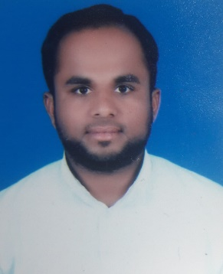

**KHURSHID ANSARI**

**DOHA - QATAR**

**Mobile No.: +974 6624 5269 / 3157 0643**

**Emil** Id: [khurshidtayyab3@gmail.com](mailto:khurshidtayyab3@gmail.com)

**ــــــــــــــــــــــــــــــــــــــــــــــــــــــــــــــــــــــــــــــــــــــــــــــــــــــــــــــــــــــــــــــــــــــــــــــــــــــــــــــــــــــــ**

**Personal Details:**

Date of Birth : 18th May 1988

Marital Status : Married

Nationality : Nepalese

Languages Known : Arabic, Hindi, Urdu & English

**Visa Status : Valid Transferable Visa with NOC**

**Passport Details:**

Passport No. : 09126600

Date of Issue : 28th August 2015

Place of Issue : Kathmandu – Nepal

Date of Expiry : 27th August 2025

**Driving License Details:**

Driving License : 28852410121

Place of Issue : Doha – QATAR

Date of Issue : 09th October 2009

Date of Expiry : 19th October 2024

**Personal Skills:**

A good team player with a positive attitude, Honest, Hardworking, result oriented and dedicated person. I know all the location, roads for Qatar

**Educational Qualification:**

High School Passed in the year 2003

**Work Experience: 15 Years**

* 5 Years working as a Light Vehicle Driver with United Development Company (UDC) Since 2018 to 2023 at Lusail, Qatar
* 10 Years’ Experience as a Light Vehicle Driver from 2009 to 2018 with Delma Marine Bots & Marine Engines, Doha, Qatar