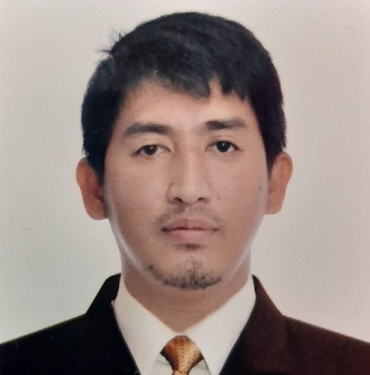JOSEPH MOJICA

 +97455780103  r_jericko@yahoo.com

 Madinat Khalifa South, Doha Qatar

**OBJECTIVE**

To obtain a position in your reputable company that will best utilize my expertise and skills.

**WORK EXPERIENCE**

**Sales Merchandiser November 20, 2021- until Present**

Qatar Trading Bosch & Karcher

* Ensure that stores, shelves, or websites are stocked with the right types and quantities of products.
* Display, arrange, price, and rotate products in-store.
* Maintain store shelves by removing dated or damaged products.
* Monitor store inventory based on sales and intake.

**Sales Representative Sept. 15, 2011 – Sept. 20, 2012**

Levis Philippines

* Meeting or exceeding sales goals.
* Negotiating all contracts with prospective clients.
* Helping determine pricing schedules for quotes, promotions, and negotiations.
* Preparing weekly and monthly reports.

**Sales Representative Aug. 19, 2018 – Sept. 27, 2010**

Bench Philippines

* Selling products or services to customers and representing the brand. This can include asking questions to pinpoint the best offerings, giving demos or presentations, and maintaining customer relationships.
* Reaching out to potential leads through a variety of channels, such as email, phone, and text.

**EDUCATION**

**Bachelor of Science in Electrical Engineering June 2000 – March 2001**

*Under Graduate*

Bulacan State University

Bulacan, Philippines

**PERSONAL BACKGROUND**

Age: 37

Gender: Male

Date Birth: March 31, 1985

Place of Birth: Quezon City, Philippines

Nationality: Filipino

Height: 178 cm.

Weight: 190 lbs.

Religion: Roman Catholic

Language: English And Tagalog

**REFERENCE**

**Ram Sharan Khadka**

Sales Merchandiser

Number: +974 66459799

**Mark James Paguntalan**

Number: +974 77945028