PERSONAL INFORMATION | MOBIN KHAN
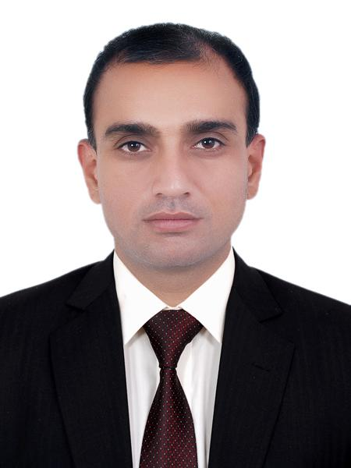 |   PHA FLAT NO. 3 BLOCK 27, GULISTANE JOHAR BLOCK 10 , KARACHI, 75290 PAKISTAN

+92-3227245802  +92-3302764008

deepmusic@gmail.com
 | Sex: Male | Date of birth 21/09/1977 | Nationality: Pakistani

JOB APPLIED FOR  POSITION  PREFERRED JOB | Reference no. 9094

WORK EXPERIENCE

Follow up Clerk  (Feb 2012- Sep 2015)  Assistant Manger  (March 2015- April 2020)  Assistant Manager  (May 2020- August 2021)  Admin Coordinator  (Oct 2021- May 2024)  Continue - | (JULPHAR Pharmaceutical Industry) Packaging Division, RAK, UAE, Responsible for monitoring the
 | product performance and striving to achieve the monthly sales target. Accountable for preparing
 | store. and marketplace updates as daily, weekly and monthly reports
and submitting to the senior management, significantly providing ideas to expand the brand lines with the key accounting manager.

(UCO Marine Contracting LLC) Operation Division, RAK, UAE ⇥ Applied the administration and logistic abilities and strategies in promoting the growth business of the limestone Aggregate exporting to Bahrain, responsible for management including storage of materials, dealing sales &amp; purchase inventory from suppliers though the firm and on to customers, also controlling accounts of the expenses during shipments, contacting suppliers and to record of all outstanding purchase orders with external vendors, review expediting schedules on all customer’s orders. Obtain and forwards information to planning and sales teams. Coordinates imports and exports. Arranges transportation and forwarding

(UCO Marine Contracting LLC) Construction Division, RAK, UAE ⇥ Dealing with building contractors, engineer architectures
And merchants/suppliers to settle building making procedures step 1 to end settlement procedures and knowledge with documented approval and clearance with involved organizations etc.

(Bank Al Habib LTD) Administration Division Call Center, Karachi, Pakistan ⇥ Working with the customer care departmental staff call center to manage administration setup of call center, i.e. maintenance of building, manage cleaners, peons, riders & messenger’s duties attendance, interviews of new staff to hire and fill the needful staff in the premises of call center, Air condition services, generators, stationaries, CCTV camera security checking to the staff etc.

EDUCATION AND TRAINING

1993 1995 2012
High School Certification Intermediate Bachelor of Commerce
Little folks School Karachi. Government National College Karachi University

PERSONAL SKILLS

Mother tongue(s) | Urdu
Other language(s) | UNDERSTANDING |  | SPEAKING |  | WRITING
Other language(s) | Listening | Reading | Spoken interaction | Spoken production
Replace with language | Fluent | Fluent | Fluent | Fluent | Fluent
 | English
Replace with language | Basic | - | Basic | Basic | -
 | French.

Communication skills | Good communication skills gained through, position of as follow.  - Assistant\t Manger Job & admin Coordinator in Call Centre Bank Al Habib Job.

Job-related skills | Worked in UCO Marine Company acquired special jobs related skills to worked with international community of all nationalities.  - good command of dealing with the customers (currently responsible for international merchants etc.)

Computer skills | - (MCSE) Microsoft Certified System Engineer Prepared Trainer  - EDP (Electronic Data Processing  - Microsoft Word & Excel  - Microsoft NT

Other skills | International music language Literate (Staff notations)  - Play Piano and compose music with professional sequencers keyboard KORG Technology.

Driving licence | - UAE driving License Valid, International Also.

ADDITIONAL INFORMATION

References | - Mansoor Ali Khan CEO-President Bank AL Habib L.T.D Pakistan

