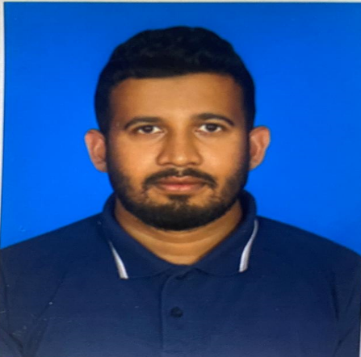  SALAHUDEEN MOHAMED ASHAD  DRIVER (Light)  Nationality : Sri Lanka  License : Qatar (Valid)   +974 50401145   Mohamed.ashad8@gmail.com   Doha - Qatar  PERSONAL STATEMENT  Efficient driver with 17 years’ experience safely transporting people and goods. Expert in planning delivery routes and schedules, interpreting maps, and analysing traffic trends to determine the fastest routes. Ready to leverage soft skills, like emotional intelligence, and hard skills, like delivery system innovation, to support solutions at Royal Mail.  LANGUAGE KNOWN:  - Arabic  - English  - Hindi  - Regional  KEY SKILLS  - Route optimisation  - Delivery, collections, and returns  - Safety regulations  - Onboarding new hires  - Vehicle maintenance  - Loading and unloading  HOBBIES & INTERESTS  - Reading newspapers  - Playing music  - Watching sports  - Go-karting | WORK EXPERIENCE  December 2021 – Present  Taxi Driver (Qatar)  Trhal Limousine Services  - Drive 100 to 200 customers per week to destinations around the city using best safety practices  - Assist passengers with luggage and packages, sometimes to their front door when needed  - Answer questions regarding local history, landmarks, restaurants and tourist attractions  - Provide narration to highlight various points of interest during a car trip when passengers want to learn more information about a location  - Picked up and dropped off high-level professionals  - Transported clients to different destinations and waited in the vehicle at drop-off points as they completed their daily tasks  - Maintained vehicle so it remains operational, including appropriate tune-ups and cleanings  April 2016 – November 2021  Company Driver (Qatar)  Aboushakrah Trading and General Services.  - Upheld all safety precautions and regulations.  - Performed daily maintenance and safety checks.  - Operated all vehicles safely and effectively.  - Kept daily pick-up records.  - Pick-up and drop Staff safely and on time.  - Following traffic laws  May 2014 – March 2016  Bus Driver (Qatar)  International British School Doha  - Obtaining and maintaining a commercial driving license  - Learning bus routes and when to arrive at each bus stop  - Helping students, particularly those with disabilities, on and off the bus  - Following traffic laws  - Making sure students are acting safely  - Maintaining order on the bus  - Reporting issues to school supervisors  - Making sure the bus is in good condition by checking important indicators like tire pressure, lights and gas levels  - Performing regular vehicle inspections and alerting the school district of any repair needs or mechanical issues  - Cleaning the bus interior and making sure it's presentable  May 2009 – December 2013  Company Driver (Saudi)  - Ability to troubleshoot and fix minor vehicle issues  - Knowledge of vehicle maintenance  - Clean driving record and extensive knowledge of traffic laws  - Punctuality  - Experience with a variety of vehicle types, such as cars, trucks, limos and delivery vans  - Flexible schedule  - Familiarity with GPS and other navigational tools  April 2007 – March 2009  Taxi Driver (Sri Lanka)  - Assist passengers with luggage and packages, sometimes to their front door when needed  - Answer questions regarding local history, landmarks, restaurants and tourist attractions  - Provide narration to highlight various points of interest during a car trip when passengers want to learn more information about a location  Declaration  Hope you will consider my candidature for a suitable post in your esteemed organisation as per my experience and proven ability.

