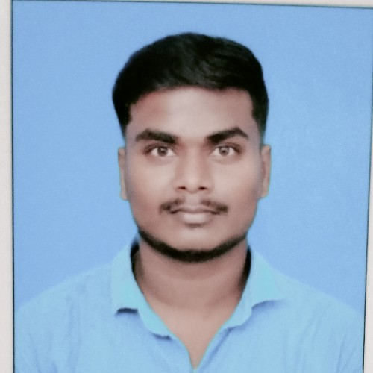
Doha- Qatar.  31617023
 kesavanelumalai1998@gmail.com

•Dedicated and experienced Supervisor cum Driver with a proven track record of
effectively managing teams and ensuring timely and safe transportation. Seeking to utilize my skills and expertise in a dynamic organization that values professionalism and excellence.

Valid Qatar car driving license (manual) Valid Indian Batch License

2014- 2015

2016-2017

2017 -2018

2017 - 2020

2022 - 2024

2021 - 2022

2020 - 2021

SSLC
Higher secondary school Land and survey Engineer BBA
Distance Educational

PICK QUICK LIMOUSINES
- Supervise a team of drivers, ensuring
adherence to schedules and safety regulation's•
- Coordinate daily transportation activities to meet customer needs and organizations•
- Conduct pre-trip and post-trip vehicle inspections to ensure roadworthiness•
- Maintain accurate records of vehicle maintenance, fuel consumption, and driver logs•
- Provide excellent customer service and address any issues or concerns promptly•
PICK QUICK LIMOUSINES
*Safely operated various vehicles to transport passengers or goods to designated locations.
*Followed traffic laws and regulations to ensure passenger safety and on-time deliveries.
- Assisted with loading and unloading of cargo, ensuring proper handling and secure transportation.
- Maintained cleanliness and orderliness of food to present a professional image to customers.
Doha - Qatar.
TALABAT

Knowledge of safety regulations and best practices•
  - Ability to multitask and prioritize tasks effectively•
  - Proficient in vehicle maintenance and repair basics•
Ability to lift and carry heavy food orders and operate a vehicle for prolonged periods of time•
Strong interpersonal skills, including verbal communication and conflict resolution Mindset for organization and attentions•
Doha- Qatar•

2018 - 2019

Naksatra construction
Working as surveyor on site orientated• Detail, Physical Stamina•
Total station and chain survey oriented• Time management skills, Visualization skills• Tamilnadan - India •

MS- EXCEL MS-WORD
Strong leadership and communication skills. Excellent driving record with a valid driver's license•

Surfing through internet

Tamil English Hindi
Full Name : Kesavan Elumalai QID Number : 29835611185
Passport Number : T880444 DOB : 21/0/1998
Gender : Male Marital status : single Country : India

I hereby declare that all the information given above is true and correct to the best of my knowledge.
KESAVAN ELUMALAI

