LAXMAN BK
CURRICULAM – VITAE

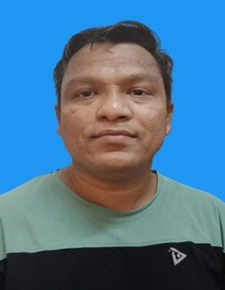
NATIONALITY: - NEPALESE
Date of birth: - 09-06-1985 MOBILE NO: - 974 30964937
laxmanrasailee123@gmail.com
Seeking New Challenges An Organization That Utilize My Skills And Opportunity For Advancement, For Your Kind Consideration I am Submitting My Details As Below.

COMPANY PROFILE
2011-2016 Anabeeb Service Company Qatar as a BA Technician & HP Jetter.
2016-2019 Senior BA Technician & HP Jetter in Aytb Ksa.
2022 Jan Bruxell Building and Contracting Company as a civil Foreman.

ACADEMIC QUALIFICATION
SLC | SHREE JAL DEVI SECONDARY SCHOOL | 2060
INTERMEDIATE | DAMAULI COLEGE | 2062
BACHLOR (BBS) | ADIKABI BHANU BHAKTA CAMPUS | 2066

PASSPORT DETAILS
Passport Number | 07936055
Date of issue | 10 October 2014
Date of expiry | 9 October 2024

Working experiences
- Driving in Nepal
- Driving in Qatar

SKILLS
- Clean Driving Records
- Ability to Drive Vehicles With Manual and Automatic
- Regular check and Vehicles maintenances
- Time Management
- Familiar with Local Traffic
- General Knowledge of Computer

Declaration
I hereby declare that the above particulars are true and correct to the best of my knowledge. Thanks & regards

Laxman Bk

