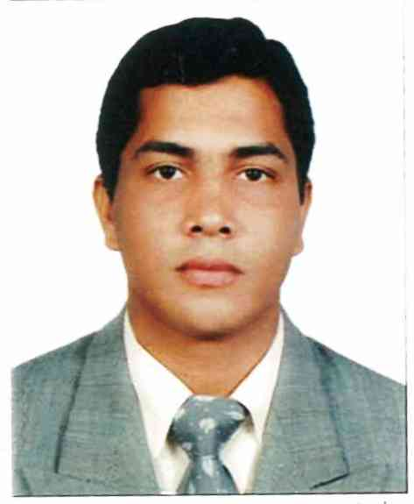

Seeking a challenging opportunity in an organization with 14 years of gulf experience that will provide

Career advancement and personal growth experience with a highly valuable application.

NAME : MD. MOHIUDDIN

FATHERS NAME : TOFAYAL AHAMED

MOTHERS NAME : RAHIMA BEGUM

PERMANENT ADDRESS : C/O NURUDDIN COMPANY HOUSE PANCHLAISH 3NO WARD,P. O WAJEDIA

P.S – BAIZID BOSTAMI, DISTRICT - CHITTAGONG BANGLADESH.

PRESENT ADDRESS: FARIZ ABDUL AZIZ, DOHA, QATAR

**MOBILE : (+974)33095378. Mohilulu24@gmail.com**

DATE OF BIRTH : 08.05.1981

NATIONALITY : BANGLADESHI

RELIGION : ISLAM

MARITAL STATUS : MARRIED

BLOOD GROUP : O+

QATAR ID NO : 28105003764 (expiry 28.11.2024)

PASSPORT NO : EH 0314219

DRIVING LICENSE : VALID QATAR HEAVY & LIGHT VEHICLE DRIVING LICENSE

**EDUCATIONAL QUALIFICATION**

Bachelor’s Degree in Commerce from National University of Bangladesh – 2004

**COMPUTER SKILLS**

MS Office Applications (MS Word, MS Excel, MS Power Point)

Internet based applications etc…

**WORK EXPERIENCE**

**Dec’2019 to Present – LULU DOHA TRANSPORTATION**

* **Working as a Transport coordinator for Hotel and school transporting**

**Mar’2017 to April’2019 – DOHA BUS (TOURISM COMPANY)**

* **Worked as a Bus captain and resort operation**

**Feb’2016 to Nov’2017 – AL EMADI SOLAR ENERGY**

* **Worked as a multi task sales support. Bill collector. PRO assistant .Boom truck operator,**

**Jun 2013 to Sep 2015 AL ABDALI GARAGE**

* **Worked as a workshop in charge (Denting, Painting ,mechanical and auto electric )**

**AL ABDALI SPARES PARTS – This is my Initial Job as a Salesman started my Career in Qatar.**

* **Worked as a salesman**

**STRENGTH AND SKILLS:**

* HOLDS THE ABILITY TO READ, WRITE AND CONSERVE FLUENTLY IN ENGLISH OFFICIALLY.
* HAVING GOOD KNOWLEDGE ABOUT THE LOCAL QATAR MARKET.
* ABILITY TO DRIVE AND GET RESULTS
* TARGET AND GOAL ORIENTED
* HARD WORKING AND DESCENT APPEARANCE MINDED.

**Declaration**

I do hereby confirm that all information given in true and to the best of my knowledge

MD.MOHIUDDIN