
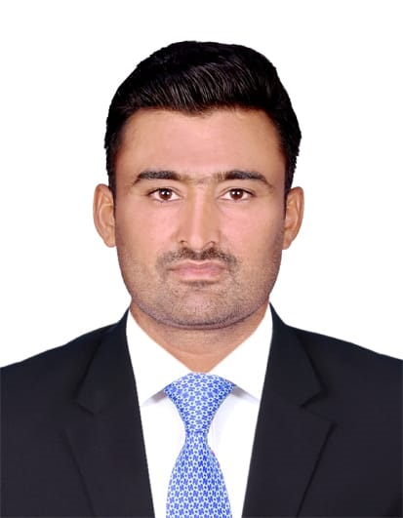

SALEEM AKHTAR
Punjab Islamabad Pakistan
Mobile #+97431468045
Saleemray21@gmail.com
Current Location Doha, Qatar
Vehicle License LIGHT CAR
Position request Assistant Surveyor (civil)

OBJECTIVE
I am keen to embark on a career where I can serve the resource in a challenging professionalabilities and interpersonal skills. Qualified for a challenging and decision making assignments. Isee myself as an active contributor to a team of dedicated and ambitions people working to help others that involve blend if team spirit and dedication.
PERSONALPROFILE
Father’sName: Muhammad Ibrahim
Date. of. Birth: 10-10-1994
N.I.C No: 36601-5064068-3
Marital Status: Single
Religion: Islam
Nationality: Pakistani
Domicile: Vehari(Punjab)
Personality: Active & Pleasant Languages: EnglishUrdu&Punjabi
ACADEMICQUALIFICATION

DEGREE | YEAR PASSING | MARKS  OBTAINED | TOTALMARKS | BOARD/UNIVERSITY
Matriculation | 2011 | 457 | 1050 | B.I.S.E.MULTAN
PROFESSIONALQUALIFICATION

DEGREE | YEAROF  PASSING | MARKS  OBTAINED | TOTAL  MARKS | BOARD/UNIVERSITY
Intermediate commerce | 2017 | 587 | 1100 | B.I.S.E MULTAN
Surveyor diploma | 2014 | 532 | 700 | Board of technical education lahore.
COMPUTERSKILLS
- 06-Months Diploma in AUTOCAD (2D,3D,3DHomeDesigning) from Cad House Information Technology Burewala.
EXPERIENCE
- 1 years as Asistant surveyor international industry limited Lahore Pakistan .
- 4 years as surveyor Izhar Group of companies in Karachi Pakistan.
- Present Image contracting as Surveyor in qatar continue......
HOBBIES
  - BookReadingAUTOCadDesignin.

