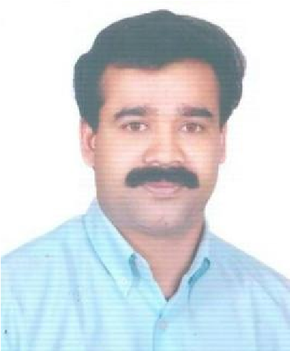

# AJAYAKUMAR.A

Mob: **+974 59912095**

Email: ajay.kallada@yahoo.com/ajay.kallada2@gmail.com



**PROFILE:**

Seek a position to utilize my 20 years of experience, skills and knowledge in the field of Sales. Desire a reputable and prominent work atmosphere within a dynamic and fast placed environment that provides opportunities for professional growth and development.

**PROFESSIONAL STRENGTHS / AREAS OF INTEREST:**

* Comprehensive Problem Solving Abilities.
* Capable of good interaction with team members.
* Effective communication skills.
* Self Motive and capable of growing with the company.
* Capable of supervision.
* Constant learner, sincere and punctuality.

**WORK HISTORY**

I)

Organization : **Middle East Son's Company LLC**

Designation : **Sales Executive**

Duration : **2012 - 2015**

II) Organization : **Arabian Oasis Food Company – Dubai (FMCG - Al seer Trading Agencies)**

# Designation : Merchandiser cum Salesman (MCS)

Duration : **2010 – 2012**

III)

# Organization : Al Mufid Trading Company L.L.C – Sharjah & Dubai – U.A.E Designation : Merchandiser cum Salesman (MCS)

Duration : **2005 – 2009**

# Organization : EPPCO (Emirates Petroleum Product Company) - Dubai

Designation : **Station Supervisor**

Duration : **2001 - 2004**

V) Organization : **Continent Hypermarket (Carrefour) at Deira City Centre.**

# Designation : Section In charge

Duration : **1998 – 2000**

# VI) Organization : Khalid Al Mana Rent A Car Company in Qatar

**Designation : Transportation Supervisor (Co-Ordination) at Qatar University Transport**

**Division From 2017 to till date**

**EDUCATIONAL QUALIFICATIONS**:

**SSLC –State Board of Secondary Education, Kerala.**

# Pre-degree - Kerala University.

# B.A History (Degree) Not completed

**PERSONAL STRENGTHS:**

* Disciplined, Dedicated and Committed.
* A Team Worker with Strong Analytical and Grasping Skills.
* Very good inter-personal skills and communication skills.
* Enthusiastic, ability to adapt to new environment and grasp work quickly.

**PERSONAL INFORMATION:**

# Name : Ajayakumar. A

|  |  |  |
| --- | --- | --- |
| **Nationality** | **:** | **Indian** |
| **Date of Birth** | **:** | **30.05.1974** |
| **Marital Status** | **:** | **Married** |
| **Gender** | **:** | **Male** |
| **Passport Number** | **:** | **M 6998803** |
| **Driving License** | **:** | **LMV (Valid Oman, Qatar Driving and UAE Driving License)** |
| **Languages Known** | **:** | **English, Hindi, Malayalam and Tamil** |

**{Read and write}slightly arabic**

**Technical Knowledge : Computer knowledge**

I declare that the above declared information is correct and true to the best of my knowledge and belief.

**Ajayakumar.A**

**+974 59912095**