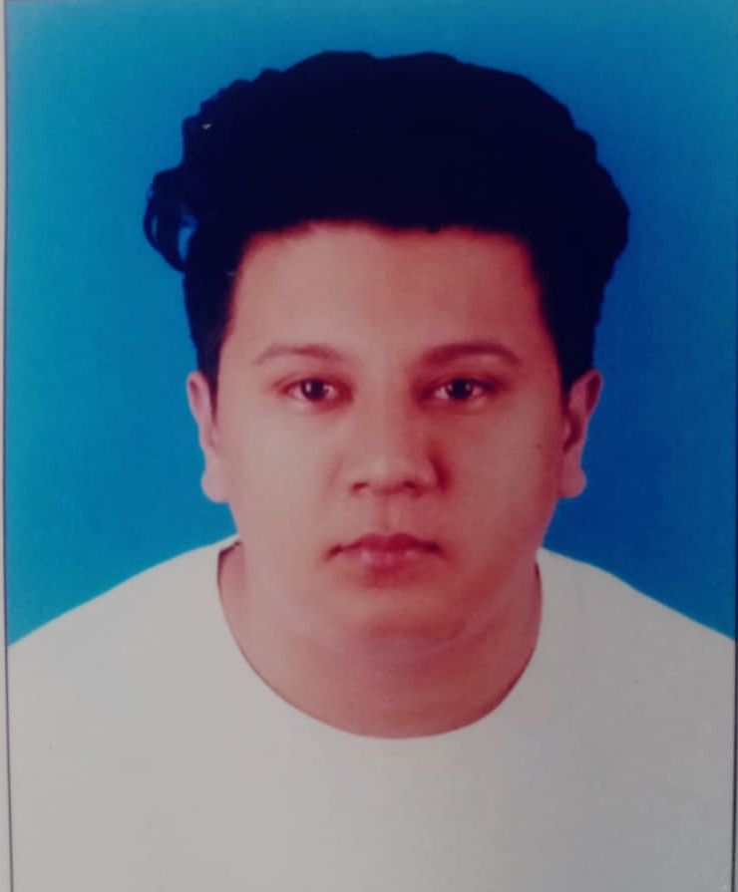

ANJIT KSHERTI SUBEDI
DOHA , QATAR

Cell No: +974-30469677
Email : anjitchetri48680@gmail.com

I’m looking forward a career-oriented job placement in
A highly prestigious organization.

PROFESSIONAL/CAREER

Designation–Gulf Regency work as delivery driver
(Jan 2021 to till date)

- Drives truck with capacity of more than 3 tons to transport and deliver cargo, materials, or damaged vehicle
- Maintains radio or telephone contact with base or supervisor to receive instructions or be dispatched to new location.

- Cleans inspects & service vehicle Operates equipment on vehicle to load, unload, or disperse cargo or materials.

- Obtains customer signature or collects payment for goods delivered and delivery charges.

Designation – Limousine Driver,Doha,Qatar (2019-Jan 2021)

- Picking up clients and safely driving them to their destinations
- Opening the door for the client to enter or exit the limo
- Ensuring that the limo is cleaned to the highest of standards, both internal and externally
- Inspect the limo to make sure it is presentable before and after each run
- Helping clients to load and unload their luggage
- Perform minor repairs on the limo if needed and taking to a garage if it needs more work
- Running errands for guests when necessary

EDUCATIONAL/QUALIFICATION

School leaving certificate: - His Majesty’s Government Board,2010
(Bharatapur, Highersec.School)

COMPUTER SKILLED & TRAINING
Qatar manual driving license Category-B
(Validity-15-03-2024)
Fundamentals of computer
MS-Words MS-Excel

PERSON SPECIFICATION

Charismatic persona, possess firm health, Kind and co-operative, Highly Competitive Self-starter, Certainty on smart work, committed to excellence, Optimistic standpoint, Result oriented, Distinctive result contributor.

Date of Birth : 30/Oct/1995
Height : 5’9”
Nationality : Nepalese
Religion : Hindu
Marital Status : Married
Language : English, Nepalese, Hindi
Passport No : 06286530

DECLARATION DETAILS

I hereby that the above information is true & correct according to best of my knowledge and Experiences.

Yours Sincerely,
ANJIT KSHERTI SUBEDI

