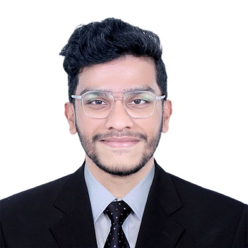 |  | BENSON TOM MATHEW  CAREER OBJECTIVE  To work with an organization where I can leverage my skills, work passionately and create sustainable business value. I am looking for an appropriate position where my knowledge and skills will make a significant contribution towards the corporate goal of the organization.
Profile  Permanent Address  Al-saad Street, Doha Qatar  Visa Status  Valid QID : 29835600405  Personal Details  Date of Birth : 26-09-1998  Gender : Male  Father’s Name : Thomas Mathew  Nationality : Indian  Religion : Christian  Marital Status : Single  Contact  Mobile +974 66267705  E-mail :bensonmathew98@gmail.com  Hobbies  - Travelling  - Music  - Playing  - Reading  Languages known  - English  - German  - Malayalam  SKILLS  - Communication & Organisational skills  - Adaptable  - Hardworking and Dedicated  - People-oriented  - Computer Literature (Word processing, Spreadsheets & Presentation) |  | EDUCATION  B.A Economics (Marian college, Kuttikanam, Kerala, India) 2016 - 2019  Primary ( CBSE ) to Higher Secondary ( CBSE ) 2014 - 2016  [M.E.S Indian School, Doha, Qatar ]  WORK EXPERIENCE  Ayra Infotech Contracting& Trading.  Period- 1 Year  Marketing executive  M/s. United Technical Trading & Contraction Co. ( Doha, Qatar )  Period: 1 Month  Internship  M/s. Techins Software Solutions LLP ( Ettumanoor, Kerala )  Period : 2 Year  Marketing Executive  M/s. Family Food Center ( Doha, Qatar )  Period: 1 Year  Sales Coordinator  M/s. Hamad International Airport (Doha, Qatar)  Period: 2 Months  Customer Service  Leadership Experience  Coordinated National Seminar  Achievements and projects  - Participated in National seminar on “ Dimensions of sustainable economic and business development”  - Did a statistical Project ‘Monetary policy of India from 1990’ - 2017  - Won various prices for competitions in school level  - Conducted study on India’s Trade Liberalization under Asia pacific trade agreement and Import from China : The case of Rubber and Rubber Products.  - Study on flood in Kerala with special reference to Idukki  - Completed ICDL Course.  DECLARATION  I hereby declare that the information given above is true and correct to the best of my knowledge and belief.  Benson Tom Mathew

